To create a profile for your church or organization, follow these steps.
- When you log into DivLink, you will see your Home page with several tabs down the side.
- The Organization Profile tab shows your Supervised Ministry site information. There are five parts or pages to this profile, which correspond with the five items under Organization Profile on the side.

This is information students will see when they are looking for Supervised Ministry sites. Therefore, one of the most important fields is “Overview.” This text field expands as you add content, so you can put as much information as you would like about your organization or church and what an internship there might look like. As part of your organization’s Profile rather than the internship posting itself, this information is visible all year as students are getting ideas about where they might like to visit.

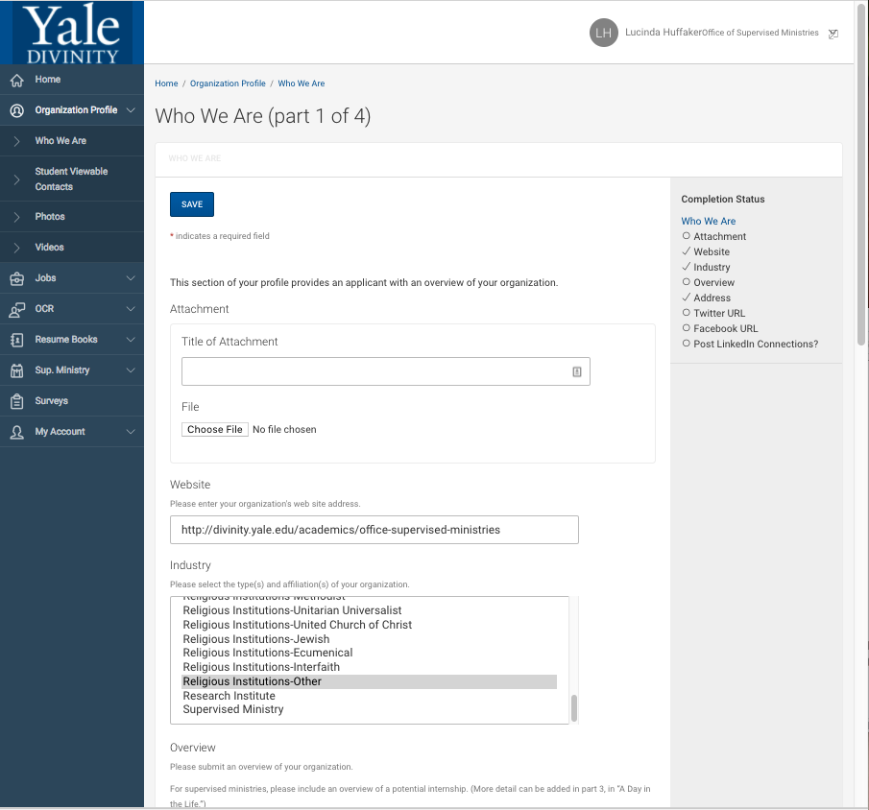
Note that there are places to attach documents, enter Facebook and Twitter links, and add a logo, photos, and videos. Remember to Save on each page.

- The My Account tab at the very bottom of the list shows your personal information.
  - Your Personal Info provides your contact information.
  - The Document Library contains a variety of information I have provided to facilitate supervision and mentoring. All of the documents pertaining to Supervised Ministries have titles that start with OSM (for Office of Supervised Ministries).
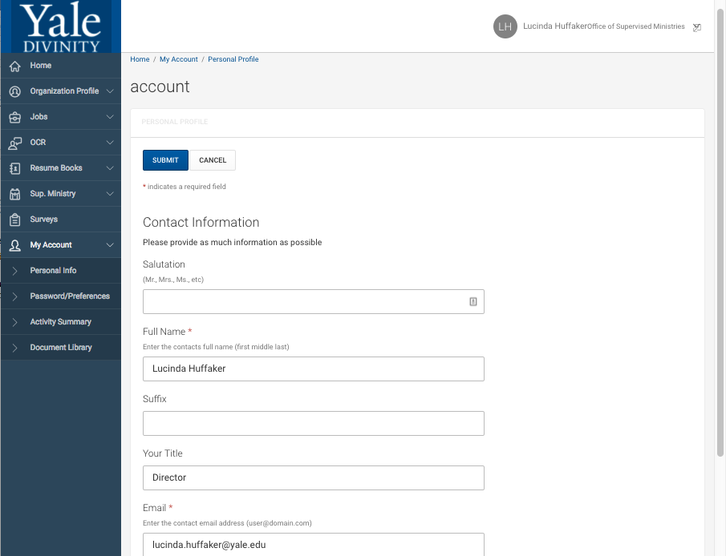

- You can log in to your DivLink account at any time, year round, to edit or update your personal and organization information. This information is always visible to students.

