Posting a YDS Supervised Ministry opportunity is a two-step process:
- Create an organization profile on DivLink, which is Yale Divinity School’s online data system.
- Post a description of the internship as a special kind of “job opening.”

Many of you will already have a profile. If you have questions about logging in, see the aids “How to Log In” and “Creating Your Profile.”

POST AN INTERNSHIP

- After you log in to DivLink, on the right side of your Home page click on “Create Job or Internship Posting” under Post a Job or Internship. The page pictured below will open.
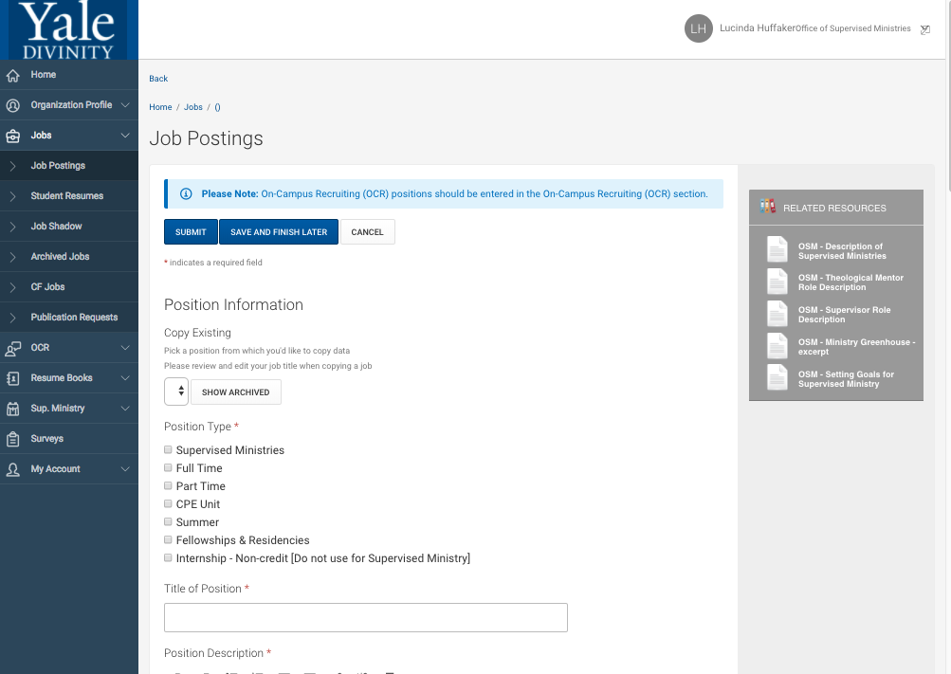

- The very first thing you do: Click on Supervised Ministries, under Position Type. This will bring up a different job posting screen that is unique to supervised ministries.

JOB POSTING SCREEN FOR SUPERVISED MINISTRY
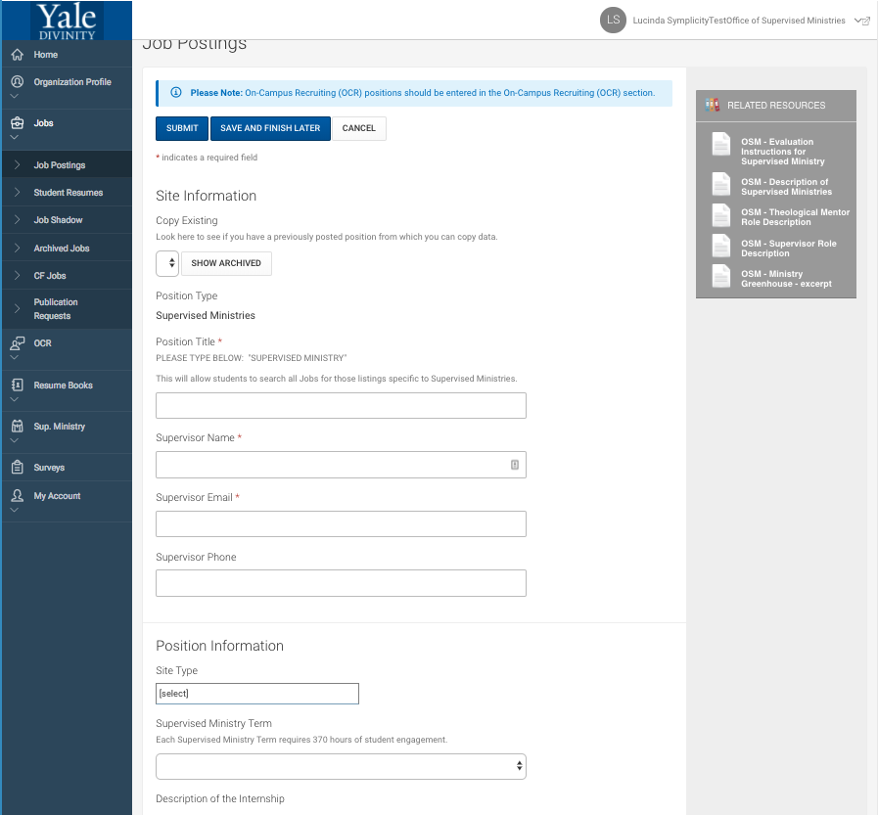

Document Library resources

See if you can revise an older version.

This is the correct page
Look here to see if there is an earlier posting that you can revise.

Note on the right side there are links to related resources that can be downloaded from the “Document Library.” The Document Library has helpful resources and forms for supervised ministry (all titles begin with OSM—for Office of Supervised Ministries), and the most pertinent are retrievable here.

- “Copy Existing”: We have placed a basic internship template on most sites. Please check the pull-down arrow and the “Show Archived” button to see if you can simply update an existing internship rather than start from scratch!

- Complete the page with as much information as possible, with special attention to “Description of the Internship.” Be sure to use descriptions of special characteristics, programs, or foci of your site that distinguish it from other sites, including words or phrases that students might use as search terms. You can also select multiple descriptors under “Site Type.” It is a good idea to type your comments in a Word document and then paste them into DivLink, and to click “Save and Finish Later” often so that you don’t lose your work. When you are finished, click “Submit.”

- After you submit a supervised ministry posting, there will be a “Not Approved” tag beside it until I have a chance to look at it. If I have any questions, I can follow up then.

- You can always edit your posted internship.

IF YOU HAVE ANY PROBLEMS WITH YOUR APPLICATION,

PLEASE DON’T HESITATE TO CALL OR EMAIL ME.

lucinda.huffaker@yale.edu

203-436-5703 (office)

765-225-8836 (cell)

