Posting a YDS Supervised Ministry opportunity is a two-step process:
- Create an organization profile on DivLink, which is Yale Divinity School’s online data system.
- Post a description of the internship as a special kind of “job opening.”

Many of you will already have a profile. If you have questions about logging in, see the aids “How to Log In” and “Creating Your Profile.”

POST AN INTERNSHIP USING THE TEMPLATE

Use these instructions if you have not previously posted an internship and have only one Supervised Ministry job listed in your Job Postings.
- After you log in to DivLink, on the right side of your Home page click on “View Job or Internship Postings” under Post a Job or Internship. The page pictured below will open.
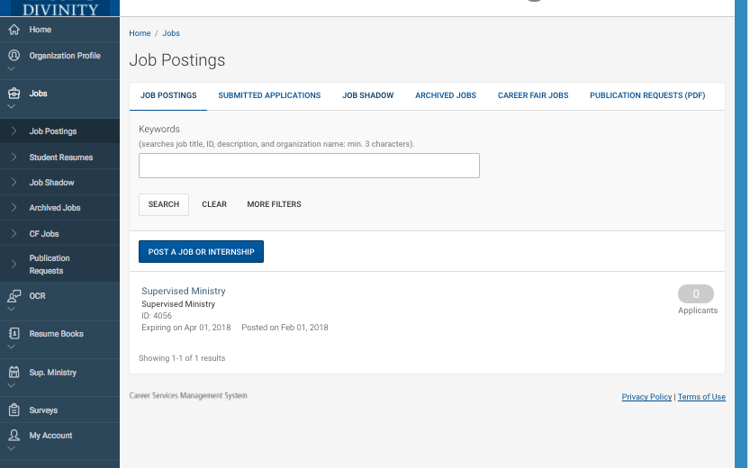

- Click on the Supervised Ministry internship. The page pictured below will open.
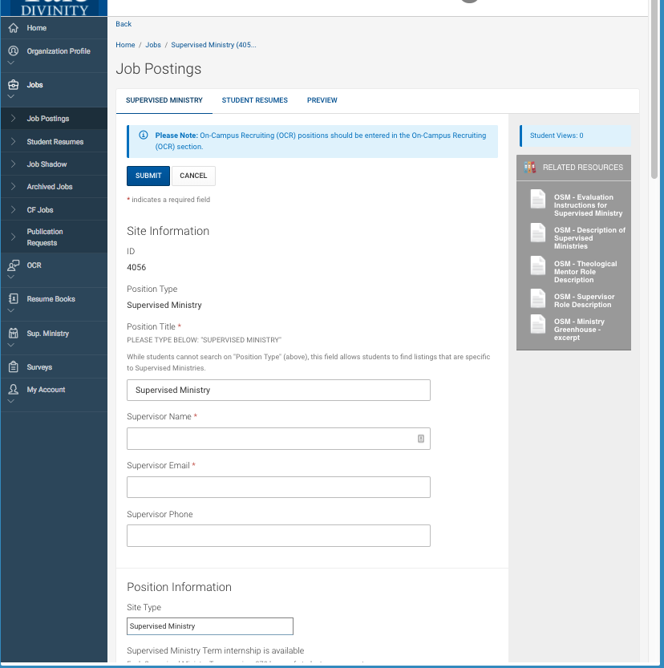

Shortcut to Document Library resources

Look here to see if there is an earlier posting that you can revise.

Note on the right side there are links to related resources that can be downloaded from the “Document Library.” The Document Library has helpful resources and forms for supervised ministry (all titles begin with OSM—for Office of Supervised Ministries), and the most pertinent are retrievable here.

- Complete the page with as much information as possible, with special attention to “Description of the Internship.” Be sure to use descriptions of special characteristics, programs, or foci of your site that distinguish it from other sites, including words or phrases that students might use as search terms. You can also select multiple descriptors under “Site Type.” It is a good idea to type your comments in a Word document and then paste them into DivLink, and to click “Save and Finish Later” often so that you don’t lose your work. Do not change the Posting Date or Expiration Date. When you are finished, click “Submit.”

- You can always edit your posted internship.

