Sites that have been in conversation with the Office of Supervised Ministries about having an intern are identified with certain “Jobs.” Some have provided specific information about internships at that site. You can search these “Jobs” (internship opportunities) by denomination, service or population focus, and key terms. To do so, follow these instructions.

- Once logged into your DivLink profile, go to the “Jobs” tab
- Click on Advanced Search
- You must narrow the jobs to only Supervised Ministries internship listings by selecting “Supervised Ministries” under the Position Type.
- You can narrow further by selecting sites who have added information about their internships. Select “Yes” under Proactive Site?
- Narrow further by selecting one or multiple items under Industry or Ministry Area (hold down Control key).
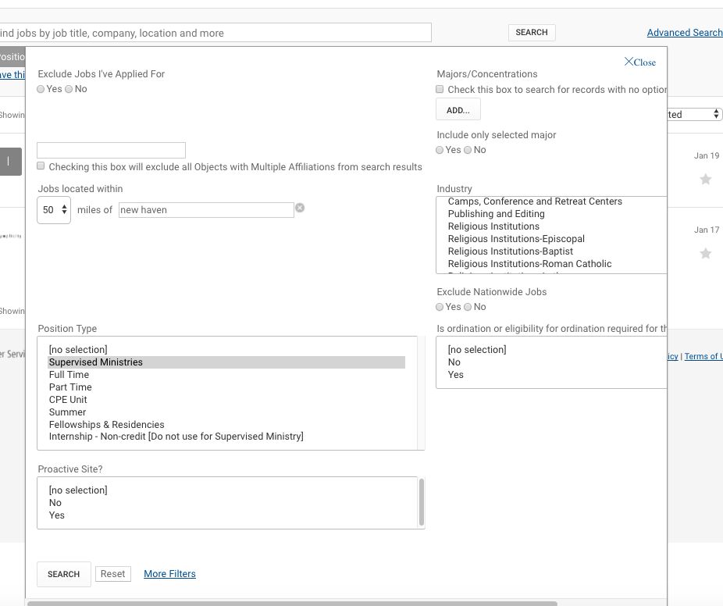
- Narrow further by adding any additional search terms, e.g., art, prison, environment.
- Click Search.

