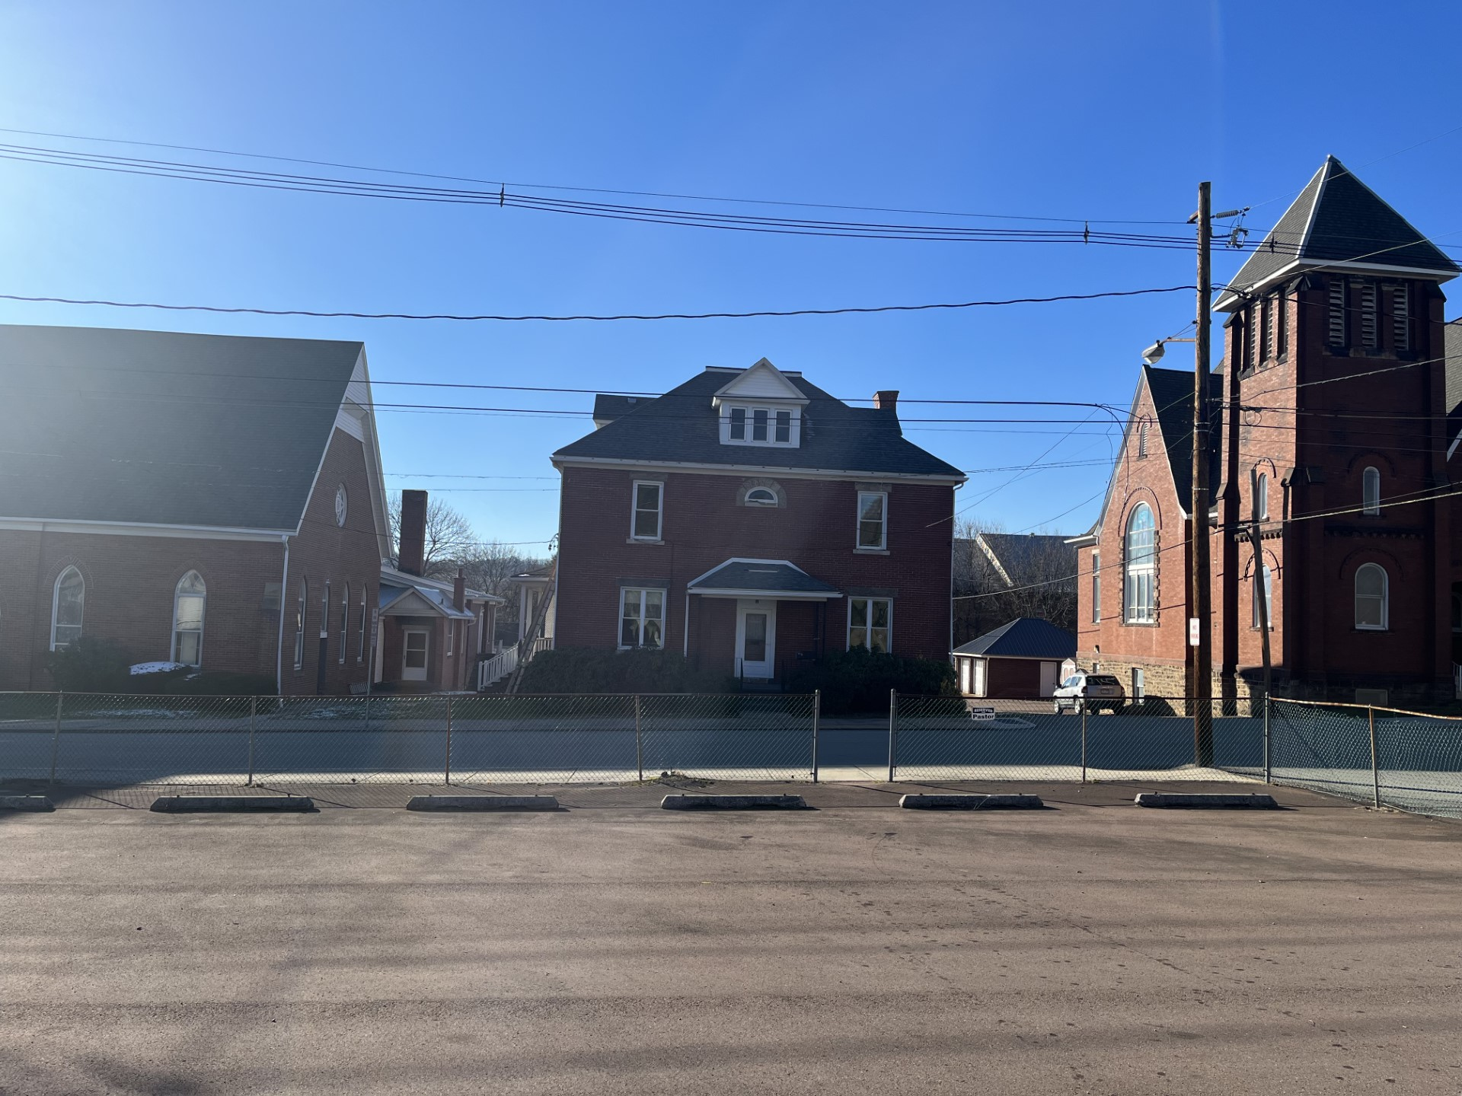

LUTHERAN CHURCH

AMITY PARSONAGE

AMITY UCC