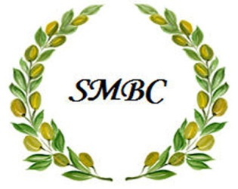

FAITH, LOVE, COMPASSION

St. Matthew Baptist Church

126 Washington Avenue

Bridgeport, CT 06604

Tel: 203.414.9366

[www.stmatthewbaptist.org](http://www.stmatthewbaptist.org) / [office@stmatthewbaptist.org](mailto:office@stmatthewbaptist.org)

Associate Minister

The primary function of the Associate Minister is to assist the senior pastor lead the church. The Associate Minister may have regular tasks assigned to him/her, or the Associate Minister may serve in whatever position he/she is needed to fill within the church. The Associate Minister is responsible to assist in the day-to-day church management with the pastor.

Compensation: Voluntary/Stipend

Responsibility/Duties:

* Participate in staff planning meetings
* Ministry Department: Ministerial Staff
* Experience: Able to serve as a support to the senior pastor, able to teach and preach the gospel, detailed oriented, professional, friendly, compassionate, dependable
* Ensure implementation of church policies and procedures
* Assist the senior pastor in overseeing the ministries of the church
* Assist with developing the ministry
* Preach when assigned and on other occasions when asked by the senior pastor
* Pray for and support the senior pastor
* Provide recommendations for solutions to ministry problems
* Participate in staff visitation and outreach
* Develop and recommend strategies for church growth and program improvements
* Represent the church at outside events/functions if needed

Rev. Dr. Aaron M. Best,

Founder and Senior Pastor

“Go thereforeand make disciples of all the nations, baptizing them in the name of the Father and of the Son and of the Holy Spirit” (Matthew 28:19/NKJV).