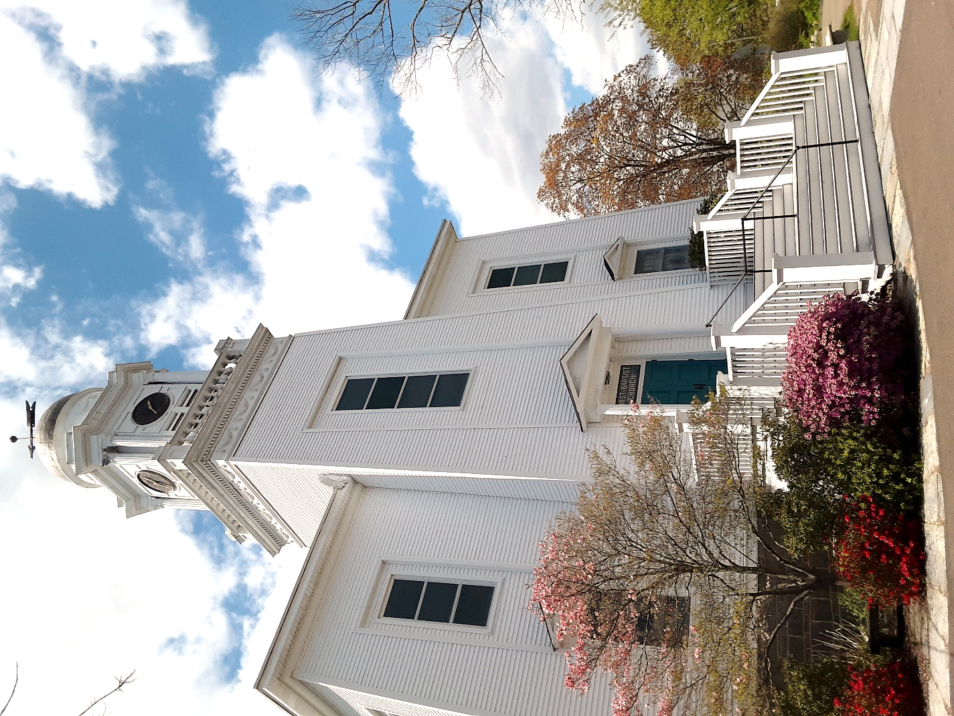

10 Prospect Street
Essex, Connecticut 06426
860-767-8623
WWW.fbcinessex.org

CHURCH INFORMATION
First Baptist Church in Essex
10 Prospect Street
Essex, Connecticut 06426
860-767-8623
WWW.fbcinessex.org

PASTORAL SEARCH COMMITTEE CHAIRPERSONS
Mark Stiber
475 E Pond Meadow Road
Westbrook, CT 06498
860-876-2489
Ironrebits@comcast.net

Linda Tuzzio
44 Comstock Avenue
Ivoryton, CT 06442
860-575-9093
Tuz06442@gmail.com

PASTORAL SEARCH COMMITTEE MEMBERS
Nina Stiber, Tina Spencer, Betsy Bochman, Wendy Kovar

