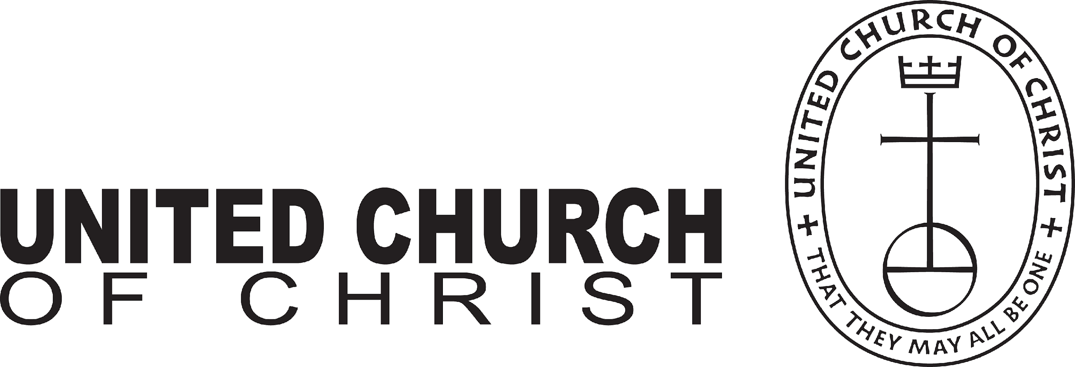
UNITED CHURCH OF CHRIST
LOCAL CHURCH PROFILE

Wellesley Hills Congregational Church UCC
207 Washington St
Wellesley Hills, MA 02481

Settled Associate Minister

Southern New England Conference of the United Church of Christ
Metropolitan Boston Association

[Validation Date]

LOCAL CHURCH PROFILE CONTENTS
- Position Posting
- Who Is God Calling Us To Become?
- Who Are We Now?
- Who Is Our Neighbor?
- References
- Consent and Validation

“God is able to provide you with every blessing, so that
having all sufficiency in all things at all times,
you may abound in every good work.”
(2 Corinthians 9:8)
INSTRUCTIONS

The new Local Church Profile supports the calling and discernment of United Church of Christ congregations with their current or future pastoral leadership.

For many congregations, the interim time between ministers is an intentional season that is guided in part by the preparation of a Local Church Profile. Using the Profile, the church can discover its data and express its story for the reliable discernment of a search committee and the beginning of a new pastorate. Searching ministers will want to see this document in its entirety.

The interim season is not the only time in a church’s life when it’s valuable to give attention to explore a congregation’s vocation. Three sections of the Local Church Profile – WHO ARE WE NOW, WHO IS OUR NEIGHBOR, and WHO IS GOD CALLING US TO BECOME – are meant to be updated every 3-5 years. Known together as the “Discovery Document,” these three sections can be completed by a visioning group, a governing body, a transition team, or other group – not just the search committee – in order to draw forward the gifts and imaginative possibilities of a congregation. The church’s engagement with the “Discovery Document” might not have the same sequence as the completed Local Church Profile that is read by candidates.

Some questions are easy to answer. Some are not so easy. Prompts are provided to stimulate narrative response if needed; these italicized prompts are merely examples from which to choose or to inspire your own. Efforts to answer the questions will prompt conversations and explorations and story-tellings and many prayers. As the Spirit moves throughout the process, congregations will shape a collective articulation of Christ’s leading (WHO IS GOD CALLING US TO BECOME). This last question to be answered becomes the first section to be read by searching ministers in the Local Church Profile, and it is the boldest and most actionable piece for faithful leadership into the future.

Your conference can provide materials referenced in the Local Church Profile, such as the 11-Year Report containing data as reported by your congregation annually to the UCC Data Hub, and MissionInsite reports containing demographic information on your community. More information on types of pastorate in the United Church of Christ can be found in the Call Agreement Workbook. Be sure to use the Call Agreement Workbook’s Scope of Work to describe in this Local Church Profile the position being sought.

When it is time for ministerial search, the conference can counsel you on posting the Local Church Profile together with your public listing at UCC Ministry Opportunities (http://oppsearch.ucc.org).

The last page of the Local Church Profile contains a statement that parallels the consent statement signed by ministers in the UCC Ministerial Profile. In keeping with the covenantal relationship between a church and those it seeks to call, this statement encourages an open, honest exchange of information. On behalf of the United Church of Christ, and on the basis of the best knowledge available to them, your conference staff will validate your completed Local Church Profile when it is ready to be shared in relationship with prospective new leaders.

1. POSITION POSTING
a. LISTING INFORMATION
b. SCOPE OF WORK
c. COMPENSATION & SUPPORT
d. WHO IS GOD CALLING TO MINISTER WITH US?

1a. LISTING INFORMATION

Church name: Wellesley Hills Congregational Church (UCC)
Street address: 207 Washington Street, Wellesley, MA 02481
Supplemental web links: www.hillschurch.org

Additional ecumenical affiliations (e.g. denominations, communions, fellowships):

Conference: Southern New England Conference of the United Church of Christ (SNEUCC)
Association: Metropolitan Boston Association
UCC Conference or Association Staff Contact Person (Name, Title, Phone, Email):
Rev. Alex Shea Will, Area Conference Minister for the Northeast Region
SheaWillA@sneucc.org Mobile: 781-369-9917

Summary Ministry Description:
In a short paragraph, reflect on where your church is going and what it might look like when you get there. What do you need to get there? Who are you seeking to join you on this part of your church’s faith journey?

We are dedicated to ensuring the continued success and vitality of our ministries, particularly our youth program. Our previous Associate Minister, after five years with us, has accepted a call as a solo pastor. We are seeking a new Associate Minister who will bring energy, creativity, love and deep faith with a particular focus on nurturing our youth, leading them in service to others, deepening their spiritual journeys and expanding participation. The candidate will work with our experienced Children’s Ministry Coordinator to oversee programs for our younger children and their families. In addition, they will participate in Sunday worship as a liturgist and preacher, be an active member of our pastoral care team, and intentionally welcome the broader Wellesley and Metrowest community into our programs and membership at the Wellesley Hills Congregational Church (“Hills Church”).
While we are seeking a dynamic leader for our youth program, we are open to the gifts and passions that a candidate will bring and are willing to discuss creative ways to serve our youth. As a large suburban church, a thriving youth program is essential to our continued vitality and growth. At the same time, we realize that ministry is rapidly changing, and our ideal candidate may not look like candidates in the past.
For over 175 years the Hills Church has emphasized liturgy, exceptional music, social justice, and service to our community and the broader world. We have recently invested in a major renovation of our facilities, funded by a successful capital campaign; called an experienced, energetic Senior Minister; and hired an exceptional Director of Music who is committed to recreating a strong music program for children and youth. The Hills Church has hosted the Wellesley Food Pantry since its founding and is a lead congregation of MetroWest Family Promise, an organization that provides shelter, food and comprehensive support to families with children who are facing homelessness. We have a long history of active participation in other service activities beyond Wellesley and Metrowest, including, but not limited to, Boston, Cambridge, Mass., Central America, and South India.
Photographs:
Insert 1 – 3 images of your church, its people, its parsonage or building or gathering space, etc
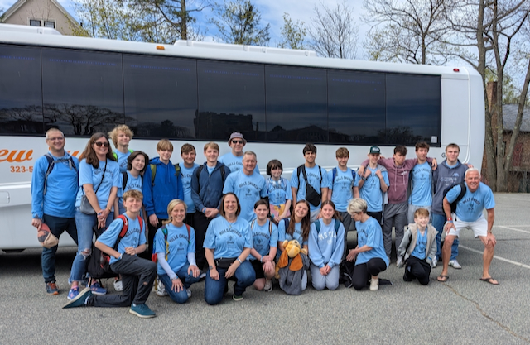
Costa Rica Mission Trip 2023
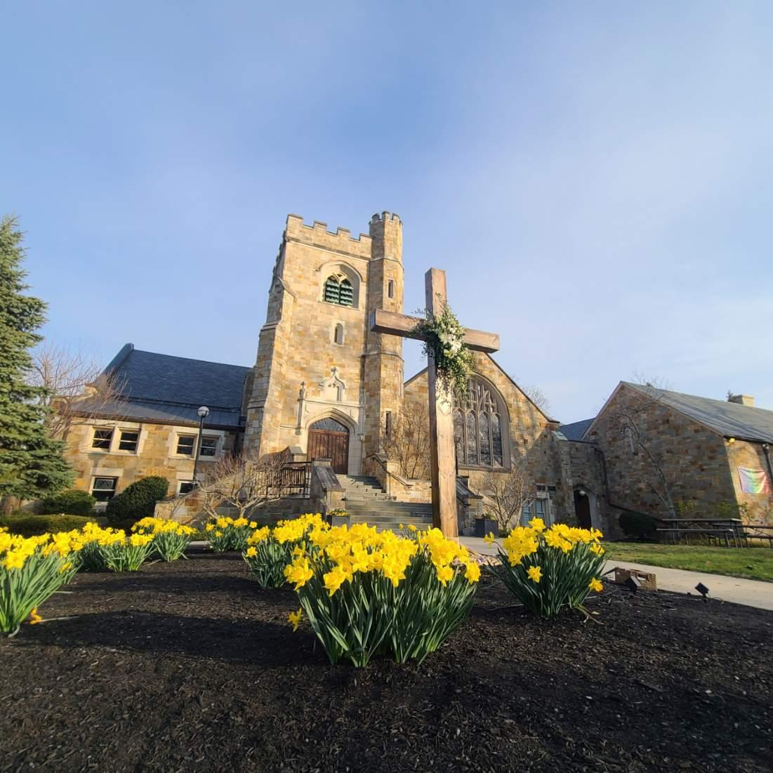

Wellesley Hills Congregational Church before Easter 2023

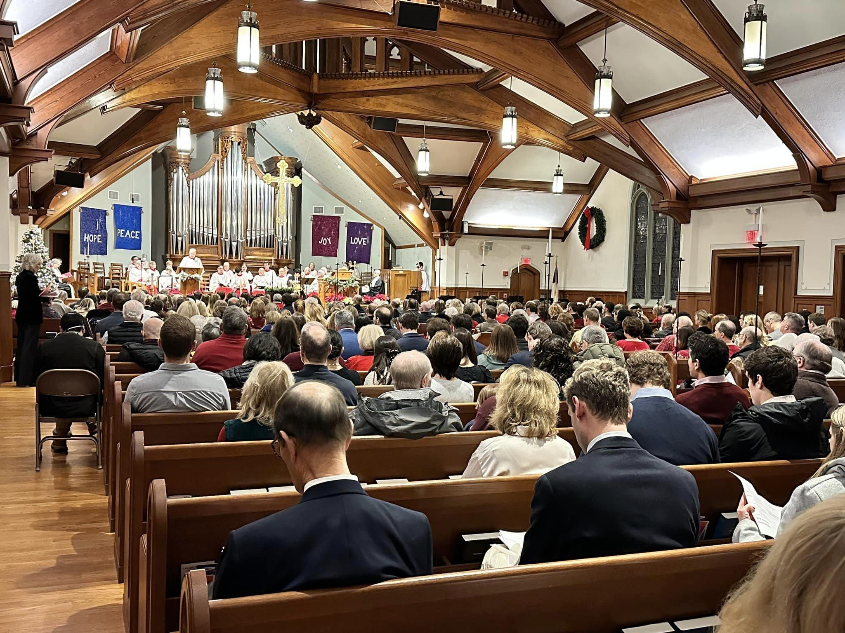

Christmas Eve 2023

We are recognized by both locals and commuters as “the Pumpkin Church”. Each October our youth, families, and other members volunteer to unload a semi-trailer truck of pumpkins onto our front lawn which we sell to raise funds for indigenous farmers in the Southwest, our Hills Church youth programs, and annual emergency relief efforts. The Pumpkin Patch also brings smiles and fond memories to our members and neighbors, young and old alike.

What we value about living in our area (2 – 3 sentences):

Wellesley is about 12 miles west of Boston; the area abounds with athletic and cultural venues, renowned healthcare, and higher education (including Wellesley College, Babson College and Massachusetts Bay Community College within Wellesley and Harvard, MIT, Boston College, and Boston University nearby) accessible by both public transportation and highways. Excellent public and private schools are available in Wellesley and surrounding communities, as are several markets, shops, and restaurants. Nearby places include: Cape Cod, the North Shore, the Berkshires, Rhode Island, the mountains of New Hampshire and Vermont, the Maine coast and lakes, and New York City.

Current size of membership: 628

Languages used in ministry (other than English): None

Position Title: Associate Minister

Position Duration (choose one, delete the other options listed):

Settled – a called position intended for longer-term ministry in which the minister moves church membership to the congregation and moves standing to related association.

Compensation Level (choose one, delete the other options listed):
Full Time

Does the total support package meet conference compensation guidelines?
The total compensation and benefits are an attractive and competitive package for the Metro Boston Association. The range for combined salary and housing allowance is $100,000 to $120,000.

1b. SCOPE OF WORK
(add here the Scope of Work developed by your church using the Call Agreement Workbook)

Core Competencies:
(List three core competencies that you imagine could be foundational in your next minister’s relationship with the church. For example, a church seeking a pastoral care minister might hope to call someone who is caring, sensitive and sociable, while a church seeking an executive minister might want an organized, detail-oriented and time-conscious person.)

1b: Scope of work
We are searching for a Full Time Associate Minister who will lead our youth program and be involved in a variety of ministries based on our needs and the candidate’s passions.
This minister will shepherd and lead the church’s ministry for and with youth and children, and create authentic relationships with youth, children, and their families. The church has an excellent Children’s Ministry Director who oversees the Church School for pre-school and elementary school. It is paramount that the Associate Minister has the ability to interact compassionately and sensitively with parishioners at all ages and stages, particularly youth at all phases of development and families of all configurations.
Essential Functions:
• Communicate to the congregation the strategic direction and vision for ministry of youth, children, and families.
- Participate in Sunday morning worship leadership as a liturgist and as a preacher generally once per month. Participate in the planning and leading of special services on holy days and seasons, including creative opportunities for worship at other times.
• Oversee the ministry programs for youth and children. The Associate Minister will provide direct leadership and counseling of middle school and high school ministry programs and youth group activities. The Associate Minister will provide a consistent presence in Sunday church school to provide leadership and teaching to support the Children’s Ministry Director.
• Develop a network of spiritually gifted teachers and mentors to empower the congregation to participate in ministry with children and youth; empower youth to find ways to serve and become a vibrant part of the wider church.
• Work with boards and ministry teams to do the work of the church, including organizing special events, adult Christian education programs and Bible studies, service opportunities, and perform other duties as they arise.
• Work with the other clergy and the Spiritual Care Support Board to provide pastoral support to the congregation.
• Collaborate with the Senior Minister as part of a team to enhance outreach via such media outlets such as Instagram, Facebook, X, etc.
Core Competencies
Teaching/Leadership– Able to articulate and share a faith understanding that is well grounded and inclusive – for all ages.
Organizational Skills – Able to gather and organize resources (e.g. people, funding, materials, support, etc.) to complete projects, service opportunities or events. Recognizes Church-wide priorities and works cooperatively with the clergy and laity.
Media Skills: Familiar with and comfortable using social media platforms such as Instagram, Facebook, X etc. to widen church’s outreach and message.
Development of volunteers – Able to engage people, discern their potential for ministry and inspire them to become involved in the church in new ways; provides appropriate training, guidance and resources for volunteers to be successful.

1c. COMPENSATION AND SUPPORT

Salary Basis (from the Call Agreement Workbook, equal to Cash Salary plus Value of Parsonage/Housing Allowance): $100,000-$120,000

Benefits (choose one):
Meets Conference guidelines

What is the expected living situation for your next minister (e.g. parsonage, living nearby with a housing allowance, living elsewhere to commute as needed)?
The church will provide a housing allowance as a part of the overall package.

Describe peer and professional supports available for ministers in your association/conference:

Wellesley Hills Congregational Church is a part of the Metropolitan Boston Association and the Southern New England Conference (SNEUCC). Both settings are among the most robust and well-staffed associations and conferences in the United Church of Christ. The Association and Conference offer a variety of workshops throughout the year for continuing education. In addition, there are “Community of Practice'' groups that offer peer support for pastors in our conference.

1d. WHO IS GOD CALLING TO MINISTER WITH US?
Describe the ministry goals you envision your next minister co-collaborating with the congregation to achieve.

Please refer to Section 2.

Describe how your vision of the minister you are now seeking will assist the congregation in making an impact beyond its walls.

The departing Associate Minister regularly led service opportunities for youth and adults in the broader community, as well as mission trips beyond the local area. We hope the incoming Associate Minister will continue this work as they feel called. There will also be opportunities for advocacy work around social justice issues, depending on the candidate’s passions and experience.

Specify language requirements or culturally-specific capacities preferred in a next ministerial leader, and why those matter to the congregation’s sense of calling.

Eastern Massachusetts is home to many immigrant groups. While many immigrants are concentrated in Boston and other large cities, Wellesley has significant numbers of South and East Asian, specifically Chinese, families. Framingham, a nearby community, is home to a large Brazilian community. This is a congregation with a remarkable degree of fluency in other languages, the result of either family background or educational training. The congregation aspires to be more diverse and to reflect the evolving racial and ethnic makeup of the broader community. The congregation and broader community is accepting and welcoming of LGBTQIA+ people and families of varying configurations.

Based on what you have learned about who your church is, who your church’s neighbor is, and who God is calling the church to become, describe four areas of excellence from The Marks of Faithful & Effective Authorized Ministry that your next minister will display to further equip the congregation’s ministry in these areas.
Our church family has had two opportunities to discern God’s vision for our church – one beginning in 2008 and the second in 2016. Both opportunities identified that one of our hallmarks – one of the values we hold dear - is to invest in our children and youth. From the final report in 2009:
“Young people and families are vital to the life of our church. We all grow deeper in our spiritual faith when we have meaningful intergenerational relationships. Our faith community is where young people can build the spiritual foundation they need to face the challenges and opportunities of their future. We make baptismal and confirmation promises to offer our love, support, and care for our children and youth. We are called to put these words into action, so our children and youth can discover the comfort and the challenge of God’s presence in their lives, even as the church becomes a place where they feel safe and valued – just as they are.”
Engaging Sacred Stories and Traditions
Today, our faith formation programs, through a combination of fun, sacred conversation, service, and prayer, are designed to encourage our children, youth, and our families to embrace learning in ways that are welcoming, creative, supportive, and faithful. Our next Associate Minister will continue to help and nurture our children, youth, and adults to foster curiosity and an understanding about how God and Jesus want us to live by using sacred stories and traditions from both Hebrew Scriptures and the New Testament in worship, Sunday School, Youth Groups, Confirmation, parent groups, and service opportunities. This will take a creative and dynamic storyteller to impart the word of God to those eager to search and believe.
Working Together for Justice and Mercy
Promoting justice through collaborative and holy relationships within the walls of our church, in our local community and beyond is integral to our culture and future growth. With an Associate Minister who has a proven history of working with others to promote justice, we will continue to provide examples and opportunities for our children, youth, and adults to become passionate about helping and serving others. As we reach out, we create a community for all to come as they are and to know that they are respected and loved – just as Jesus respects and loves each of us. Everyone, particularly our children and youth, should continue to feel the radical hospitality of God while having opportunities to express that hospitality to others.
Strengthening Inter- and Intra- Personal Assets
While our new Associate Minister must have excellent verbal and written communication skills and proven organizational talent, this person must be able to build a supportive and collaborative relationship with children and their families in which compassion and support are offered – especially during challenging times. These challenges may affect siblings, parents, grandparents, friends, and others in our extended church community. Thus, having the ability and passion to minister to all ages – young and old – is necessary.
Caring for All Creation
To provide this kind of support and hope, our new Associate Minister must be able to practice self-care including attending to their own spiritual and pastoral care. Our church’s Pastor- Parish Relations (PPR) team provides, for each minister, support and assistance in a confidential environment. In addition, each minister is assigned a “buddy” from PPR with whom they share a personal and supportive relationship. The SNEUCC offers many opportunities for growth and guidance including, but not limited to, a New Clergy Group (NCG), Communities of Practice groups, and trainings. We not only expect a person to provide care and show compassion for all, but also we want our new minister to know how to maintain a life balance given all the demands placed on a settled associate minister.

2. WHO IS GOD CALLING US TO BECOME?
“You shall love the Lord your God with all your heart, and with all your soul, and with all your mind.” (Matthew 22:37 NRSV)

Who is God calling you to become as a congregation?
During 2008 and 2009, as mentioned above, the Hills Church entered into a period of discernment to clarify the mission and purpose for the future of our church, focusing on the following three questions: 1. Who are we as a church? 2. What are we here for? And 3. What great things do God and the congregation dream for our church? The visioning hallmarks which emerged reflected our response to God and the hopes of our congregation. An additional hallmark was added in 2016 after addressing the question, “Who is God calling you to become?” The five Visioning Hallmarks, which are the core values that serve as the foundation of our church’s mission, are:
· Deepen Our Spiritual Journeys
· Invest in Children and Youth
· Foster Authentic Relationships
· Welcome, Invite & Involve Our Neighbors
· Care for Others Through Outreach
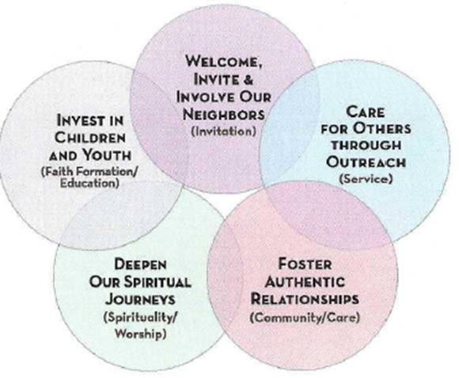
Deepen Our Spiritual Journeys
From the 2009 report: “In our Visioning Process, the Hills Church expressed a strongly felt longing for a deeper encounter with God.” There is a yearning to talk about “things that matter”, “to go deep and wrestle with questions.” Because we are a church which welcomes religious and theological diversity, we have taken on the challenge “to find a common language through which we can talk about God together. The vision we have discerned suggests that the more such conversations we have, the more rewarding our sense of God will become.”
Opportunities for spiritual development and faith enrichment occur in worship services, which are at the center of our church life, and in small and large group gatherings. “A Word for All Ages” is often part of the service, with children sitting, wiggling, or standing on the steps of the chancel while listening to age-old messages or singing. Current small group offerings include a weekly lectionary study, Paul’s Letter to the Galatians and Confirmation for Adults. The Morning Meditation Ministry supports meditation on verses from the Bible and prayers, and offers a variety of practices to enable entering the stillness of God. Rich musical offerings, including Special Music Sundays, enable opportunities for deep reflection, introspection and joyous singing.
Invest in Children and Youth
We believe that we are called to put the baptismal and confirmation promises we made to our children and to the wider church into action by nurturing faith in a just, forgiving, and loving God. We strive to develop a strong spiritual foundation in our children and youth by providing a rich program of opportunities to serve within and outside of the walls of our church.
The Children’s Ministry’s Church School nurtures a whole faith experience for preschool through grade 5 children through Bible stories, activities, crafts, videos and games. In addition to church school, children have helped to set up communion, unloaded pumpkins for the annual Pumpkin Patch, sponsored a family at Christmas, given all church families Lent packages and teddy bears, and sung in the Cherub or Children’s Choir. The annual Community Egg Hunt and open to all Christmas Pageant are beloved yearly activities. Vegetables and herbs grown in a nearby community garden are given to the Wellesley Food Pantry.
A wide variety of Youth Group, Confirmation, and Backyard Ministry activities are offered for youth in middle and high school. They gather for breakfast on many Sunday mornings and attend church services together. Justice and service initiatives include baking cookies, and making sandwiches and snack packs for unsheltered people for the ministries of the Outdoor Church and Common Cathedral. Youth who participated in the recent service trip to Costa Rica had a packed schedule of learning, service and adventure! The peak of the service activities was two days hosting “field days” for 30 enthusiastic children from a two-room local elementary school. Our youth organized physical activities, and everyone tried to learn each other’s languages and cultures. The youth brought supplies for arts and craft projects and physical education activities. The youth also journeyed through the Children’s Eternal Rainforest where they repaired trail fences, cleared miles of hiking paths, and painted a children’s learning center. During the service trip, the group learned facts about Costa Rica, and the hosting organization, Led2Serve, shared how we can use our gifts and our abundance to help others and to care for each other and our world.
Foster Authentic Relationships
From the 2009 report: “A major strength of the Hills Church is the web of deep, authentic relationships among its members and friends… We seek to be more intentional in building even deeper and more meaningful connections with each other and with God”.
The Hills Church has a strong sense of community. From an Advent study group’s discussion of Maya Angelou’s poetry to a small intergenerational group’s mission of baking communion bread, and a small group’s study of Howard Thurman’s Jesus and the Disinherited, these short-term opportunities help foster deeper relationships. The Care Team Ministry reaches out to individuals who are experiencing the joys of a new birth, or the sorrow of illness or loss of a loved one, providing meals, rides, cards and other measures of comfort and support. A Community Hour is offered after Sunday worship services. The Community Hour and the Advent Workshop with the outdoor Christmas tree lighting are a couple of examples of large group gatherings which help foster authentic and lasting relationships.
Welcome, Invite and Involve Our Neighbors
From our website, “At the Hills Church, no matter who you are, no matter where you are on life’s journey, you are truly welcome here—and will be accepted and loved—for just being you.” We endeavor to spread this message to neighbors, both near and within the broader community. We warmly welcome neighbors to a church life that supports faithful worship and the search for God during joyful gatherings as well as suffering, poverty, injustice, and the knowledge of ourselves as fallible human beings. Church life supports our search for meaningful answers to the deeper questions of life.
The Membership Ministry Team and our wider church community facilitate outreach activities, welcome visitors to Community Hour, provide information sessions about the church, and pair visitors with church members to help introduce them to the church and its wide variety of offerings, if desired. Neighbors are invited to events including our annual Easter Egg Hunt, Pumpkin Patch, and Cookies with Santa. Our church website, www.hillschurch.org, is a rich source of information for getting to know about us. Church services are live streamed and can be viewed through our church website and on YouTube. Our Events at the Hills newsletter is distributed weekly on-line to anyone who wishes, and details the many opportunities and offerings of our welcoming church.
Care for Others Through Outreach
From the 2016 report, we are here “To exemplify God’s love through service,” and “To be the hands and feet and heart of Christ in the world.” The two focus areas of our Christian Service Support Board in 2022 were “Reducing economic and social inequality in our metropolitan Boston community; and Serving the needs of refugees, immigrants, and other needy groups in the global community of which we are a part.”
The Hills Church offers many opportunities for outreach and service: Common Cathedral, Outdoor Church, Christmas Gifts for Low Income Families, Wellesley Food Pantry, a clothing drive for Second Chances, Habitat for Humanity, and Family Promise, a national program that provides temporary shelter, meals and support for homeless families. Examples of outreach activities world-wide include: our participation in a partnership with the Siddi community in rural India through the African Indian Alliance, the recent youth service trip to Costa Rica mentioned above, and our engagement with Honduras Hope to two marginalized communities in Honduras.

Describe how God is calling you to reach out to address the emerging challenges and opportunities of your community and congregation.
For example, describe two experiments your congregation has initiated or engaged in the past year, what were the results and where do you see your next steps? Has your church had a multi-year strategic plan or vision statement; if so, where do you see that plan/vision taking you?

The Hills Church faces many of the same challenges that other UCC and mainline churches face these days. The two biggest issues are the loosening of ties among members during the Covid pandemic and the need to attract new members.

Given the present challenges, the new senior minister has highlighted four areas of focus to address these challenges. These include:

1. Sunday worship. Sunday worship is at the heart of our communal life. The church is lucky to have recently hired an excellent Director of Music after the previous Director of Music retired after thirty-nine years. The church has a strong liturgical and musical tradition. We strive for excellence in all aspects of worship and are looking for a new Associate Minister who has a passion for worship and is open to growing in that role. The person needs to be willing to work collegially with the other clergy and staff to plan worship.

2. Deepening Our Spiritual Lives. While Sunday worship is at the center of our spiritual life, there is a need for everyone to continue to nurture in their spiritual journey outside Sunday worship. This past year we launched a new small group ministry with a variety of offerings including: Bible study and theology groups, meditation, a group that integrates body and spirituality, and fellowship and justice-focused groups. We also have ongoing fellowship opportunities for seniors and the broader congregation. We would like to continue to grow these important efforts.

3. Focus on Community Outreach. The Covid pandemic forced most churches to focus inward to survive. Now that we have emerged from the pandemic, we need to re-energize our outreach efforts. The Hills Church historically focused on giving to local non-profits and volunteering to help many of these organizations. A critical area of outreach has always been engaging our youth in service activities. Building on this success, going forward we would like to identify specific issues and needs in our community and local context that we can study and work to effect lasting and impactful change. In our current religious context, people need to see and know the Hills Church as a place that furthers Jesus’ vision of the kindom/kingdom of God.

4. Evangelism. The Hills Church has a large footprint in the community. Many people know of the church or have loose affiliations with it. We need to leverage our community events (such as the Community Egg Hunt, Pumpkin Patch, Special Music Sundays, etc.) to invite people to visit us on Sunday morning. This year our new Director of Music has re-launched our children’s choir based on the Royal College of Music curriculum to attract families with children. We need a cohesive social media strategy, and we want to explore targeted advertising in our community and develop neighborhood outreach strategies. We also want to advertise beyond our community since The Hills Church is one of the few mainline churches in our area with a vibrant children and youth program. We would love a new Associate Minister who has creative approaches to evangelism in the 21st century.

To support these efforts, we have implemented a new church database software program this past year, which we want to use more effectively going forward. We are passionate about bringing people into relationship with God and Jesus. The church does a lot of effective ministry now, and we are confident that we can do even more with the right Associate Minister on the team.

3. WHO ARE WE NOW?
“You shall love your neighbor as yourself.” (Matthew 22:39 NRSV)
a. CONGREGATIONAL REFLECTIONS
b. 11-YEAR REPORT
c. CONGREGATIONAL DEMOGRAPHICS
d. PARTICIPATION AND STAFFING
e. CHURCH FINANCES
f. HISTORICAL INFORMATION

3a. CONGREGATIONAL REFLECTIONS ________

Describe your congregation’s life of faith.
For example, what beliefs and commitments are stated in your congregation’s purpose statement or membership vows? How is God most often described in worship liturgy? In what ways would you describe the Holy Spirit in your midst?

To respond to this question we looked carefully at a report from our Strategic Visioning Team (SVT) published in April 2021 that surveyed who we are as a church, our spiritual health, and our practices and then made a series of recommendations for us to consider going forward. Listed below are a few examples of what our members shared with the SVT on the question Why are we here as the Hills Church?

“We are here to serve our community through our outreach and to be examples of acceptance and kindness through our fellowship with one another as well as in our larger communities. “

“To be a force for good in the world.”

“To grow and live out our faith in a truly caring community of God. To learn to live as Jesus taught. To experience faith, where we learn to give more than we receive.”

“To renew our faith, inspire our service, pass our faith along to those who come after us, support one another in times of joy, and sorrow, praise God for all our blessings and seek God’s nearer presence at all times, including times of need. To learn to see God in and be God to each other. To find purpose in life and peace in death.”

Based on feedback received by the SVT, they concluded we have a strong set of existing programs and that, “instead of developing new programs, the challenge will be to decide how (existing) programs might be more invitational, better communicated, or better scheduled to involve more people, and new people.”

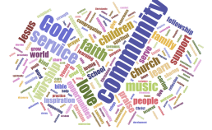

While our life of faith is underpinned by our sense of community and service, there is no question that it is the Gospels and especially the words of Jesus that motivate our congregation. It is a faith that is lived, more than spoken about. Nevertheless, the weekly lectionary readings and sermons have a profound effect and are often a source of light and wisdom cited in meetings or gatherings at Hills Church. One could say it is touched with a bit of New England ethic of reserve – no one would describe us as deeply evangelical – but we love our church, and it is often what attracts new members to us. We try every day to live our faith with the help of our fellow congregants, our ministers and lay leaders, and the Holy Spirit.

Describe several strengths or positive qualities of your congregation.

As part of our November 2021 survey of the congregation, we asked respondents to evaluate statements about the church in thirteen different areas. The ones ranked highest were related to:
- Commitment to Christ, I see my church as Very Dedicated
- Fellowship, I see my church as Warm and Personal
- Stewardship, I see my church as Generous and Open-hearted
- Service to others in the community, I see my church as Active and Concerned
The results of the survey tell us something but don’t really get to the essence – the spirit – of the church. This word cloud from our recent survey of the congregation asking them what brings them to church provides a broad overview.
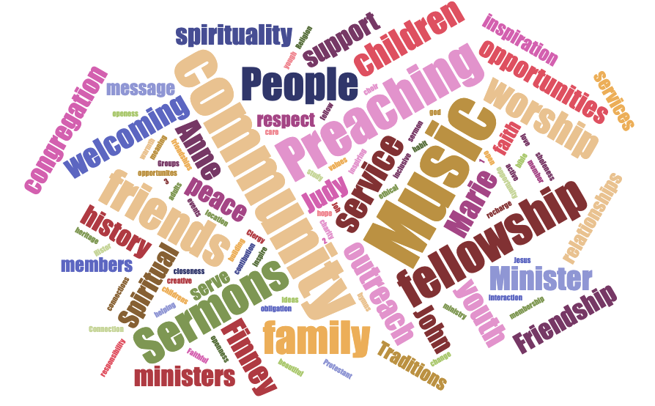
Wellesley Hills Congregational Church is a place of worship where people are eager to come. There is an energy when you enter the church each Sunday morning. People are happy to see one another. They inquire after those who may be absent, asking: “Do they need something? What can be done to help?” The music unites us all. We listen with appreciation; we sing with gusto.
We enjoy our fellowship opportunities as well, both for adults and for families. Coffee hour after service is well attended by both adults and children. Other fellowship activities range from progressive suppers for adults, the Gingerbread House making, or game nights for families. Many of our celebratory get-togethers are advertised town-wide: Cookies with Santa, the lighting of the Christmas tree, the Easter Egg Hunt, and the October Pumpkin Patch.
The spirit of the church is best revealed on a weekday morning. The parking lot is very often active if not full around the comings and goings of the children and their families attending the vibrant nursery school within our building. Other activities include: people going to meetings or reading groups, several regular community endeavors held at the church, dropping off goods for the Wellesley Food Pantry, and a variety of annual charitable drives. This is a church community that wants to help. The ground is fertile right now for a burst of energy as we channel the grace and resources we have been given.

Describe what worship is like when your congregation gathers.
For example, where does worship take place, and what is it based around? What was a recent baptism like? What are some words used to describe good preaching?

Sunday morning worship at the Hills Church is at 10:00 a.m. and lasts for about an hour, and sometimes a bit longer. The deacons or others greet all attendees at the two main entrances. It’s a joyful time with many conversations among members; parents settling children at childcare or Church School; informal conversations in the halls; the choir doing a run-through; folks taking the opportunity to go to one of the adjacent offices on church business.
The liturgy is more formal than in many UCC churches. The service begins with an organ prelude, followed by Sentences from Scripture that call the faithful to worship. The choir, dressed in cassocks and surplices, process during the opening hymn. The congregation collectively confesses its sins, receives an Assurance of Pardon, and is reminded of the Summary of the Law from Jesus, that we are called to love God and one another. On some Sundays we have a children’s moment and then the whole congregation shares the Peace of Christ. A prayer and the reading of Scripture follow. It is the custom of the church to hear the concerns and celebrations of the congregation, which bind us together as a community and are summed up in a Pastoral Prayer. Music is a significant part of our worship. Our excellent Chancel Choir sings an anthem or a soloist sings either after the reading or during the Offertory. The service concludes with the Sermon, Recessional Hymn, and Benediction. The congregation remains attentively seated until the conclusion of the Organ Postlude.
Additional Comments:
There are many variations on the service depending on the liturgical season and special events, including Advent, Christmas, Lent, Easter, Pentecost, All Saints Sunday, Thanksgiving Sunday, and twice annual Special Music Sundays. The spring season is a busy time for “special services”: Children’s services, Confirmation, honoring graduates, commissioning service trips, and other events. Baptisms take place during a Sunday morning worship service so that the congregation can pledge its support to anyone of any age being baptized. It’s a joyful time for all, but babies bring a special smile to every face. There are gifts from the deacons: flower, candle, and blanket. The minister doing the baptism carries the infant down the center aisle so everyone can see. It’s a pleasure to see the delighted and proud parents' faces and watch the sweet antics of the baby and young family members. The Confirmation journey is a nine-month long series of interactions between clergy, adult volunteers and youth as they grow into a deeper understanding and commitment to their faith. It culminates in a Spring worship service during which each youth is recognized and invited to speak of the meaning of the confirmation process. Once confirmed, the Confirmands become full voting members of the Church family.
Holy Communion is usually celebrated on the first Sunday of every month and at selected other services such as during Holy Week. The Open Table “for all” language spoken at the beginning of Communion is very meaningful, especially for members who come from faith traditions where Communion was “for the many” but not necessarily all.
Wallace Chapel is an intimate worship space, currently being used for various special services and activities such as youth services and Wednesday night services during Lent. It has its own organ, and stained glass highlighting our New England Congregational forebears designed with input from former Senior Minister Jack Wallace. We recently removed the fixed pews and provided moveable and stackable chairs instead. Consequently, this more flexible seating arrangement allows for more varied uses of the unique chapel space.

Describe the educational program/faith formation vision of your church.
For example, how are young people in leadership? How do people continue to form their faith over a lifetime? Name a topic studied or curriculum used recently; what was the impact of this study on those who attended?

As our children grow and learn, our faith formation program expands to include room for this nurturing process. Our faith formation programs invite both our young children (pre-K to grade 5) and our youth (grade 6 to grade 12) to discover their God given gifts and then experience God’s love by using their gifts in many ways. Our young people are provided with opportunities to explore the stories of our faith. Our children and youth are given opportunities to find creative ways to express an understanding of God’s love. They are invited to wonder about God, Jesus and the Holy Spirit. Our children are taught how important it is to be builders of God’s Kin-dom in the here and the now through frequent service opportunities.

Our middle school and high school youth are encouraged to serve in leadership roles at our church by participating as members of support boards or ministry teams. Our high school youth lead service projects and participate as liturgists in worship.

Our grade 9 and grade 10 youth participate in a year-long Confirmation Class that meets weekly on Sunday evenings with the Associate Minister and a Deacon of our church. We utilize a curriculum for this dynamic faith formation experience called, Confirm Not Conform. This curriculum encourages our youth to take a courageous step forward to discover and express their own beliefs about God, Jesus, The Holy Spirit and God’s Church. This curriculum, combined with a shared meal and other faithful experiences, has formed the basis of what has been an extraordinary journey of faith for our teens (and our church leadership).

Youth Group programming is also offered to our teens in middle school and high school on Sunday mornings and Sunday evenings to encourage friendships and to build community.

Adult faith formation takes several forms. We hold a weekly Bible study before worship on Sunday, led by an Associate Minister. There are occasional outside speakers who talk on a variety of topics, from theology to history and current issues in the community. During Lent and the fall we have a broad range of small groups. We also have many opportunities for fellowship, including our Seniors Ministry, Men’s Breakfast, Parents’ Night Out, and Summer Suppers.

Describe how your congregation is organized for ministry and mission.
For example, how are decisions communicated in your church? How are teams or committees organized? Where does your church struggle for vision?
- When it comes to decision-making, how many hours are spent in meetings per month?
As a congregational church, the governance is largely conducted through meetings of our Support Boards, Council, Ministry Teams, and Moderators. The Ministers actively take part in these meetings and are expected to attend multiple meetings each week.

- Think of a time when action had to be taken quickly, for example when a crisis or disaster occurred. How was that accomplished?

Over a weekend in early March 2020, we learned that a member of the congregation had been hospitalized for a respiratory illness consistent with Covid-19 infection. Although this individual thankfully tested negative for Covid-19, we did not have that information until that Sunday afternoon by which point we had already canceled several events including the worship service.

The Moderators sent out an email message to the congregation that weekend which contained guidance about how to minimize exposure to, and the spread of, Covid-19, and reliable sources of information (including links to websites). The Covid-19 situation continued to evolve rapidly, so a conference call of church leadership including the clergy, the Moderators, the Senior Deacons and members of the Safe Church Ministry Team was held on the following Friday. During this conference call a decision was made to cancel all gatherings at the church, including those of the community groups that use our facilities, for two weeks. This decision was consistent with similar closures and meeting restrictions in the public schools and other local houses of worship, as well as with guidance from SNEUCC.

Once it became clear in early 2020 that Covid-19 was going to be a long-term issue and we realized that we would not be able to gather in the church for some unknown extended period of time, the ministers, music director, choir soloists and technologically savvy members of the congregation teamed up to create recorded versions of our worship services which were posted on our website. Worship leaders, including the organist and choir soloists, taped themselves individually, and the segments were technically “stitched” together. Fortunately, our then Senior Minister turned out to have innate talents as a film editor!

The Church Council created a Re-Opening Task Force led by a former Moderator who was a physician. This Task Force was empowered to make on the spot decisions to modify or cancel activities and to communicate with the congregation.

The pandemic prompted us to accelerate the development of our capabilities for video recording/streaming worship services. In addition, most meetings of our governance Boards and Ministry Teams moved to Zoom.

While our worship services and other many other activities of the church are now in-person, we have made a commitment to being inclusive. Currently, we use technology to ensure all - including those who are cautious about being in public gatherings or those who live at a distance - can participate in both worship service and the other activities of the church. We have hired professionals so that the streaming of our worship services can make one feel as if one is in the sanctuary. Church meetings, small groups, and our Annual Meeting are conducted both in person and over Zoom. This model guarantees all who want to participate can. The involvement of a significant number of attendees in all these areas tells us that our efforts are meaningful to all the members of our church family.

- Can you provide the next minister with a copy of an organization structure, bylaws and/or annual report to further explain the patterns of the church’s activity and governance? [Yes/No]

The Bylaws have been extensively revised over the past seven years and further revisions are frequently voted at our Annual Meeting. The Bylaws are available to members through our website. A set of Governance Guidelines, basically a user’s manual for church governance, was approved by the Church Council on November 9, 2021. Both the Bylaws and Governance Guidelines will be made available to candidates during the discernment process.

The new governance structure embodies the elements of the UCC model based on Ministry Teams and Support Boards, all of which reside on the foundation of the five Visioning Hallmarks, to fulfill the church’s mission in the world. This enhanced structure is captured in the newly updated and redesigned church organization chart, current as of November 2021:
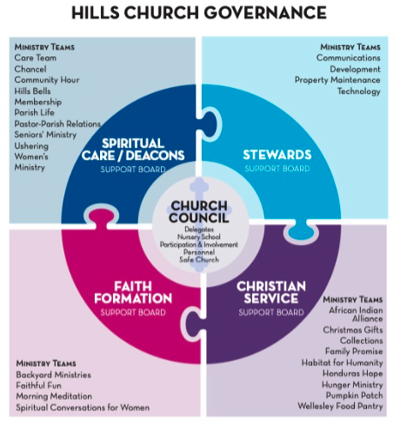
As the main governing body of the church, Church Council sits at the center of the organization acting, per the Bylaws, “for the congregation between congregational meetings.” The four Support Boards (SB), which carry out the ministries of the congregation, are intentionally broad and the range of help they provide to their respective Ministry Teams.

An important piece of the governance structure is the Ministry Team (MT), whose fluid nature, with no elected participants but only those who volunteer and feel called to the ministry in question, means that they are not individually named in the Bylaws but described only broadly in terms of responsibilities and requirements. The presence and work of Ministry Teams should be lifted up on a regular and enthusiastic basis as the new governance structure is designed to provide a wide range of opportunities for church members, and others, to serve the church’s broader mission.

In some cases, special requirements for church operations intervene, requiring the involvement of members who have the knowledge and experience to manage these areas. These areas are deemed too essential to church operations to rely on individuals who might come and go freely, as with other Ministry Teams, or do not have the required skill sets for the area of concern. To address such needs, Special Ministry Teams (SMT) have been put in place. An example is Participation & Involvement whose central role in assisting congregational members in discerning their volunteer roles and preparing the annual slate of Officers, Support Board members, and other nominees is seen as essential to the ongoing operations of the church. The selection of Special Ministry Team members, whether elected, appointed, or volunteer, varies from one Special Ministry Team to another.

3b. 11-YEAR REPORT
(add here the 11-Year Report developed with the help of your conference staff, UCC Data Hub, and MissionInsite)
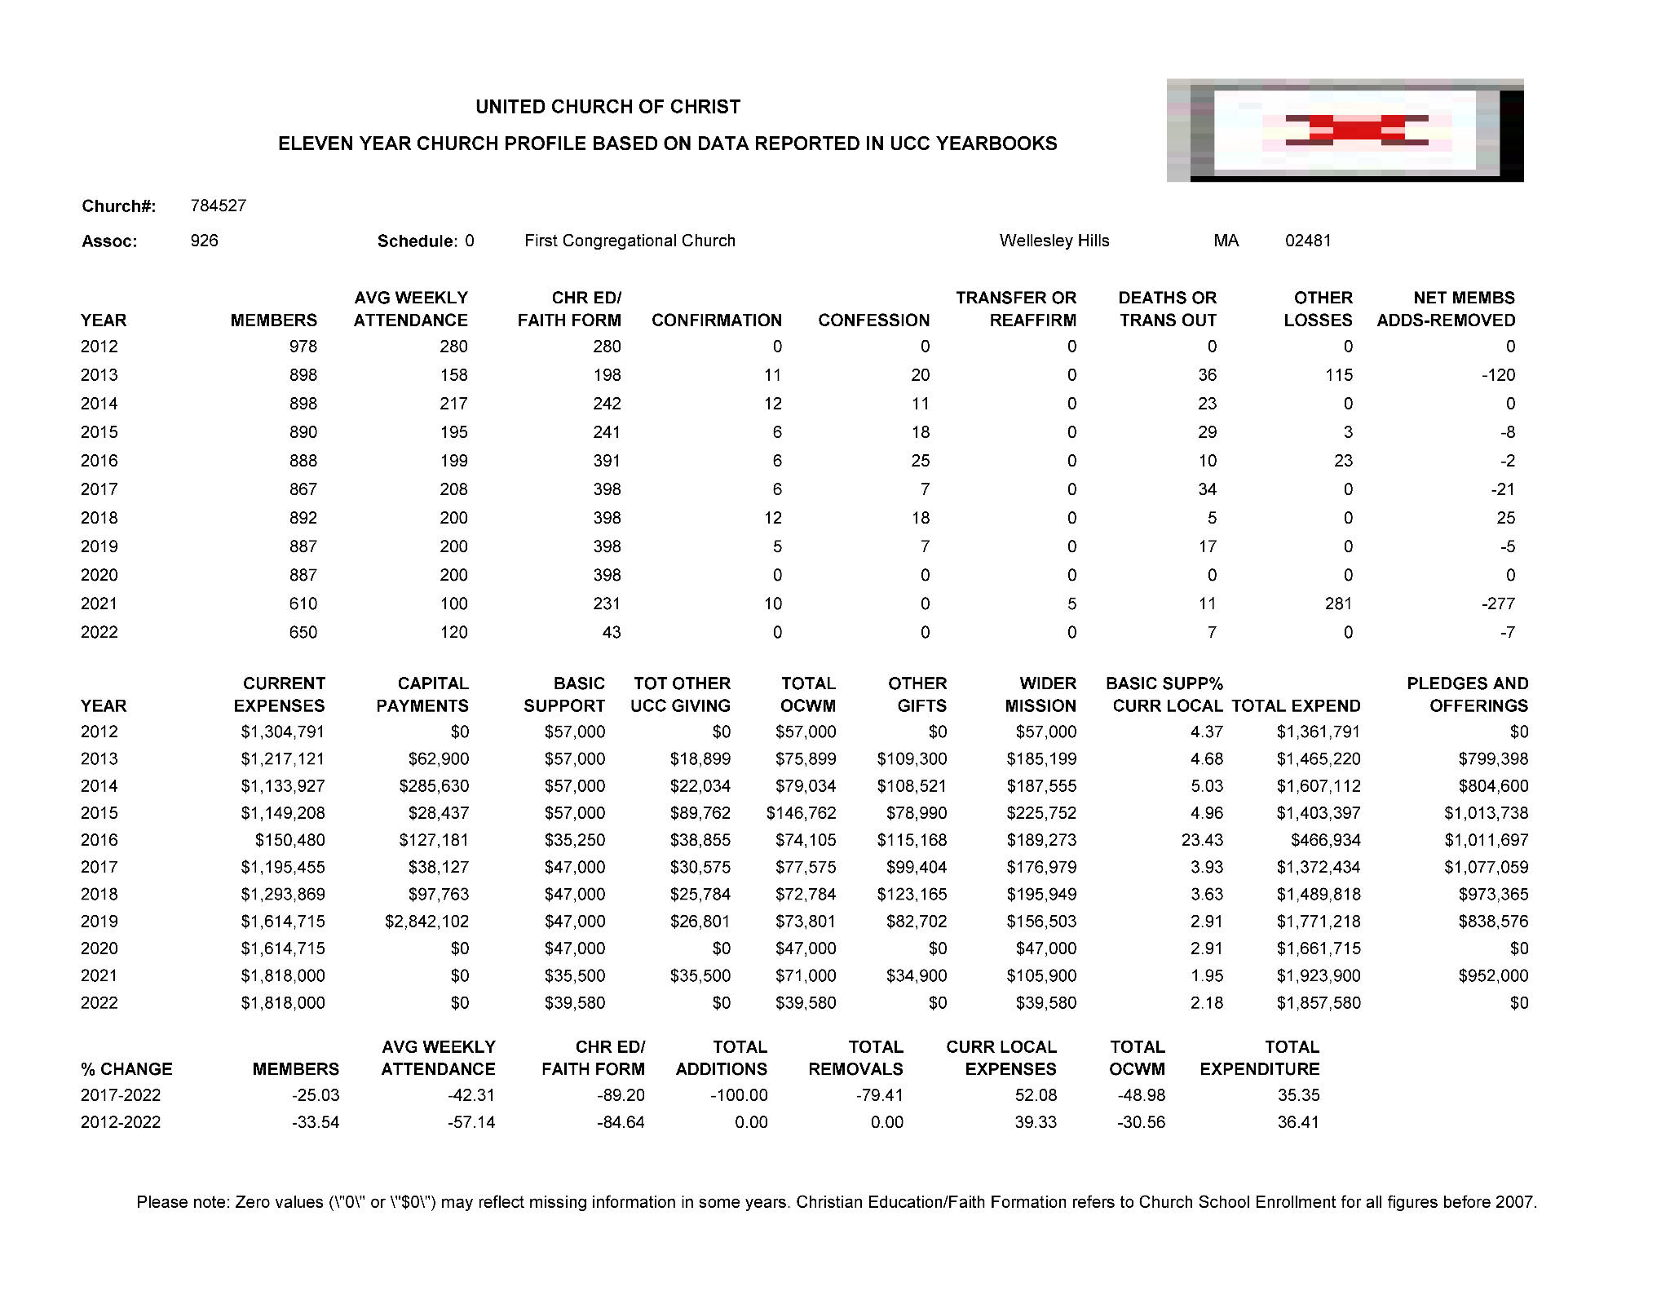
*2016 - we are aware of the difference and believe it is an aberration

3c. CONGREGATIONAL DEMOGRAPHICS ____
Describe those who participate in your church.
Below are rough estimates of the current demographics of the congregation. Given the years of pandemic, there may be changes in our estimates of expected membership once the post-pandemic world becomes clearer.

 |  | Is this number an estimate? (check if yes)
Number of active members: | 510 | yes
Number of non-active members: | 120 | yes
Total of church participants (sum of the numbers above): | 630 | yes

Percentage of total participants who have been in the church:
 |  | Is this number an estimate? (check if yes)
More than 10 years: | 50% | yes
Less than 10, more than 5 years: | 30% | yes
Less than 5 years: | 20% | yes
Number of total participants by age:

0-11 | 12-17 | 18-24 | 25-34 | 35-44 | 45-54 | 55-64 | 65-74 | 75+ | Are these numbers an estimate? (check if yes)
85 | 35 | 20 | 50 | 55 | 65 | 75 | 75 | 50 | yes

Percentage of adults in various household types:
 |  | Is this number an estimate? (check if yes)
Households with minors: | 44% | yes
Single adults age 35-65: | 3% | yes
Joint households with no minors: | 43% | yes
Single adults over 65: | 10% | yes

Education level of adult participants by percentage:
 |  | Is this number an estimate? (check if yes)
High school: | 5% | yes
College: | 40% | yes
Graduate School: | 50% | yes
Specialty Training: | 5% | yes
Other (please specify):

Percentage of adults in various employment types:
 |  | Is this number an estimate? (check if yes)
Adults who are employed: | 60% | yes
Adults who are retired: | 20% | yes
Adults who are not fully employed: | 20% | yes

Describe the range of occupations of working adults in the congregation:

Many of the congregants work in business and professional jobs that require at least a college degree. This includes several people in the healthcare field, legal services, banking and financial services, and biotech. Many people are also employed in educational institutions.

Describe the mix of ethnic heritages in your congregation, and the overall racial make-up. Most UCC congregations tend to describe themselves as “diverse.” Yet, the vast majority of UCC congregations are mono-cultural. What does diversity mean in your context?

Our congregation very much reflects the Boston Metrowest community in being predominantly white/European, affluent, well-educated, and white collar/professional. We live in an environment where we tend to make certain assumptions about one another’s backgrounds, and to take certain life experiences, especially educational and professional ones, for granted. We recognize that our mindset poses an unconscious barrier between us and people who do not share this life experience, but we wish to become more diverse by truly welcoming everyone, no matter what their race, ethnicity, sexual orientation, income or education.

The one aspect of the congregation which is somewhat diverse is the religious background of our members. Although we include a contingent of cradle Congregationalists, most of our members were raised in other Protestant denominations or as Roman Catholics. In fact, converts from Catholicism are our largest group after cradle Congregationalists, as is common in many Protestant churches in New England where Roman Catholics constitute the majority of the population.

Has your congregation recently had a conversation about welcoming diversity, or do you plan to hold one in the near future (perhaps using, for example, the Welcoming Diversity Inventory)? Please note the date. Comment after the exercise:
Following the murder of George Floyd in 2020, the congregation formed a Racial Justice Working Group, which has already provided the congregation with many opportunities to think about diversity and inclusion as well as some proposed ways to continue the conversation. Using small groups and personal experiences has been a powerful avenue for many to examine their own beliefs and their readiness for change.
In addition, as in any large church with many initiatives and teams, the work can become siloed. When the Membership Ministry Team decided to print interior banners and cards of welcome, it was evident that the work of the ONA Task Force could be of great help particularly in terms of wording. The Racial Justice Working Group and ONA Task Force are now meeting as one group as they plan next steps for greater inclusion and community advocacy.
3d. PARTICIPATION AND STAFFING

Complete the following chart. Please leave blank any fields that are not applicable to your congregation.
Ways of Gathering | Estimated number of people involved in attendance | Who plans each of the listed gatherings? (list any and all worship planners, such as various lay leaders, pastors, musicians, other staff)
Adult Groups or Classes | 4 - 40 | Clergy, lay leaders
Baptisms (number last year) | 6 (2023) | Clergy, Deacons
Children’s Groups or Classes | Average 30 | Staff, Clergy, Church volunteers
Christmas Eve and Easter Worship | 500-700 | Clergy, Staff, Lay leaders, Chancel Choir, Bells, families
Church-wide Meals | Depends - at max 120 (Hoedown) | Lay leaders
Choirs and Music Groups | 40 | Director of Music/ Chancel Choir/ Bell Choir/
Church-based Bible Study | Average 5-10 people | Clergy
Communion (served how often?) | Monthly | Clergy/Deacons
Community Meals | 5 | Clergy/ Lay leaders/ Food Pantry
Confirmation (number confirmed last year) | 7 | Associate Minister of Youth and Families/Deacon
Drama or Dance Program
Funerals (number last year) | 5 (2023)
Intergenerational Groups |  | Associate Minister of Youth and Families, Director of Church School, Lay Leaders, Volunteers, Families
Outdoor Worship | 25-75 | Clergy
Prayer or Meditation Groups | 10-20 | Clergy
Public Advocacy Work
Retreats | None since Covid | Clergy/Deacons
Theology or Bible Programs in the Community |  | Clergy
Worship (time slot: 10:00 - 11:00) | 125-225 | All Clergy, Staff, Lay leaders, Deacons, Chancel Choir, Bell Choir
Young Adult Groups or Classes | 15-25 | Clergy, Lay leaders
Youth Groups or Classes | 15-25 | Clergy, Lay leaders, volunteers
Other

List all members or regular participants in your congregation who are ordained, licensed, or commissioned ministers. Indicate those with current United Church of Christ Three-Way Covenants (i.e. serving in a congregation) or Four-Way Covenants (i.e. serving in a ministry beyond a congregation).
Name | Three- or Four-Way Covenant? | Ministry Setting | Type of Ministry Role | Retired?  (Y or N)
Becky Williams | No - Licensed by Cooperative Baptist Fellowship | Academy | Teaching Faculty | Y
Robert Williams | No - Ordained by Cooperative Baptist Fellowship | U.S. Army | Chaplain | Y
Rev. Deborah Thornton | 3 | Hospital | Chaplain | Y
Rev. Suzanne Woolston Bossert | No | Outside of the Church walls | Works with homeless addicts with therapy dog | N
If one or more previous pastors or retired ministers currently hold membership in the church, describe their role(s) in the life of the congregation:

List all current staff, including ministers. Exclude the position you are seeking to fill. Indicate which staff person serves as head of staff.
Staff Position | Head of Staff? | Compensation (full time, part time, volunteer) | Supervised by | Length of Tenure for current person in this position
Senior Minister -  Rev. Jonathan Page | Yes | Full-Time |  | 2023-Present
Associate Minister - Rev. Judy Swahnberg | No | Full-Time | Senior Minister | 2011-Present
Children’s Ministry Coordinator - Sally Tomasetti | No | ¾ Time | Senior Minister | 2010-Present
Early Childhood Music Director - Emily Gauther | No | Part-Time | Children’s Ministry Coordinator | 2006-Present
Music Director - Will Cooper | No | Full-Time | Senior Minister | 2023-Present
Director of Wellesley Nursery School in the Hills - Melanie Dawson | No | Full-Time | Senior Minister | 2021-Present
Church Administrator - Andrea Bellarosa | No | Full-Time | Senior Minister | 2022-Present
Sexton - Brian Aucoin | No | Part-Time | Church Administrator | 2008-Present
Controller - John Dooley | No | Part-Time | Senior Minister | 2018-Present

REFLECTION
Reflection: After reviewing the congregational demographics and activities above, what does this information reflect about your congregation’s overall ministry?

When compared to the U.S. population as a whole, the membership of the Wellesley Hills Congregational Church reflects a disproportionate number of professionals and other highly educated individuals. While the Hills Church has a large older population, it also has an emerging youth population, which is evident in the weekly Church School Program. Our church values a strong and vibrant community as is demonstrated by the church picnic, care team ministry and the Summer Suppers. We also cherish our music program, including our Chancel Choir led by the music director and organist. The Church School Program enjoys healthy weekly attendance (coming back slowly after Covid) and the congregation is supportive of its music and community. Our hope is to inspire our youth to participate in our spiritual community or other faith communities throughout their lives.

3e. CHURCH FINANCES

Current annual income (dollars used during most recent fiscal year)

Source | 2023 | 2022
Annual Offerings and Pledged Giving | $887,005 | $948,720
Endowment Proceeds (as permitted within spending policy, such as a cap of typically 4.5%-5% on total return) | See below* | See below*
Endowment Draw (beyond what is permitted by spending policy, “drawing down the principal”) | See below* | See below*
Fundraising Events | $169,276 | $102,657
Gifts Designated for a Specific Purpose | $0 | $0
Grants | $0 | $0
Rentals of Church Building | $0 | $0
Rentals of Church Parsonage | $0 | $0
Support from Related Organizations (e.g. Women’s Group) | Included in fundraising | Included in fundraising
Transfers from Special Accounts | $0 | $0
Other (specify): Operation of the Nursery School, net | $417,048 | $383,463
Other (specify): | $0 | $
TOTAL | $1,473,329 | $1,434,840

*Each year the Church intends to draw from the Endowment not more than 4% of the three year average of the total investment funds. The Church did not draw from the Endowment during the three years 2021 to 2023 and was able to restore some of the monies withdrawn earlier during the renovation campaign.

Current annual expenses (dollars budgeted for most recent fiscal year): $
Attach most recent church budget, spending plan, operating statement, or annual treasurer’s report as shared publicly with the congregation, or – if your church does not pass an annual budget – list current budgeted expenses here.

2022 $1,465,524
2023 $1,641,987

Considering total budgeted expenses for the year, compare total ministerial support. What is the percentage?

27%

Has the church ever failed to pay its financial obligations to a minister of the church?

No

Is your church 5-for-5, i.e. does it include each of the following contributions during the church year? (indicate those included during the most recent fiscal year)
_x_ Our Church’s Wider Mission (OCWM – Basic Support)
_ _ One Great Hour of Sharing
__ Strengthen the Church
__ Neighbors in Need
__ Christmas Fund

In what way is OCWM (Basic Support) gathered? If calculated as a percentage of operating budget, what is that percentage? (recommended 10%)

The church contributes money to OCWM from the operating budget. The amount is determined by the Stewards Support Board, in consultation with the Senior Minister, and is presented in the annual budget to the congregation. It is not currently calculated as a percentage of the budget.

What is the church’s current indebtedness?

The church has no debt currently.

If a building program is projected or underway, describe it, including the projected start/end date of the building project and the total project budget.

During 2019 and 2020, the church undertook a major renovation project at a cost of $6,024,494. One major component of the renovation was the installation of a fire protection system and an up-to-date alarm system throughout the three principal buildings. The other component was the replacement of oil-fired boilers with gas-fired boilers and extensive renovation of the HVAC systems in all three buildings including upgrading or installing air conditioning in the Parish House and the Sanctuary. The project was completed on time in September 2020, and within budget.

If the church has had capital campaigns in the last ten years, describe:
In order to fund the infrastructure renovations mentioned above, the church contracted with Walsh Associates to develop and carry out a major capital campaign. The most recent previous capital campaign had been in 2008.

Year(s) | Purpose | Goal | Result | Impact
2019-22 | Renovations | $4,000,000 | $5,325,000* | Permitted completion of project without the need for a long-term loan.

*Non-testamentary pledges to be collected over 2020-2022
If a capital campaign is underway or anticipated, describe: N/A

Describe the prominent mission component(s) involved in the most recent (or current) capital campaign.

The mission of this campaign was safety and stewardship of our physical plant. We were seeking funds to update a superannuated heating system which was becoming unreliable and increasingly expensive to maintain, and to bring our buildings up to code with respect to fire safety.

Does your church have an endowment?

Yes

What is the market value of the assets?

As of 12/31/2023 the invested assets were $4,725,000

Are funds drawn as needed, regularly, or under certain circumstances?

They are drawn as needed. The policy is to draw not more than 4% of the average of the last three years total investment funds.

What is the percentage rate of draw (last year, compared to 5 years ago)?

The Church made no draws in the last three years and in fact returned over $400,000 to the endowment. The Church drew funds in five of the preceding seven years, including $1,000,000 to partially fund a major renovation project.

Describe draw on endowment, if any, to meet operating budget expenses for the most recent year and the past five years:

See above.

At the current rate of draw, how long might the endowment last?

The endowment is growing and is expected to last indefinitely.

Please comment on the above calculations or estimates:

No additional comment.

Other Assets

No

Does your church have a parsonage?

Yes
Fair market rental value of the parsonage: $75,000/y
How is the parsonage used? As housing for the Senior Minister and family.
Street / City / State / Zip: 19 Chapel Place, Wellesley Hills, MA 02481
Finished square footage: Approximately 3,400
Number of Bedrooms, Number of Bathrooms: 4 Bedrooms, 2 and ½ baths
Assessed real estate value: Not relevant – Used for Senior Minister
Available for minister residence: Y/N Y - For Senior Minister
Expected minister residence: Y/N Y – For Senior Minister
Condition of structure, systems and appliances: Good condition
Entity in the church responsible for review and needed repairs: Property Maintenance Ministry/Stewards Support Board

Describe all buildings owned by the church: The main buildings are the Church (Sanctuary, Parish House, Wallace Chapel) and the Parsonage.

The air-conditioned Sanctuary seats 500; Wallace Chapel seats 125.
The three-floor Parish House houses the nursery school, the church library, church staff offices, reception room, small kitchen, eight church school classrooms, and two larger rooms (used for Youth Fellowship purposes and our Children’s music program).
The parsonage is a gracious two-story colonial with a two-car garage.

Describe non-owned buildings or space used or rented by the church:

None

Which spaces are accessible to wheelchairs? (worship space, pulpit, fellowship space, facilities, etc.)

Approximately 90% of our spaces are accessible to wheelchairs.

Reflection: After reviewing the church’s finances and assets described above, what does this information reflect about your congregation’s mission and ministry?
For example, when was a time the church made a major budget change? How is the budgeting process done? What new ministry initiative has your church financed?

The financial information above reflects a church that is stable from a financial perspective and one that has been a thoughtful steward of its resources. In addition, given that approximately 15% of the annual budget is earmarked for outreach initiatives to assist other local, national, and international organizations, our church is committed to the mission of using its time and resources to assist others in need.

The congregation has consistently demonstrated its generosity with steady annual contributions and consistent commitment to the mission of the church, with member donations funding the vast majority of church expenses during the year. The success of the recent capital campaign also speaks to the support the church enjoys from its members. The church has ancillary income from the nursery school, as well as investment income.

3f. HISTORICAL INFORMATION

Name one to three significant happenings in the history of your church that have shaped the identity of your congregation. Add the most important event in the life of your church in the past 10 years.

1. Length of time Senior Ministers have stayed with our church
- The church had a senior minister for 32 years which many members assumed was the norm.
- Then, the following two senior ministers left after 5 and 7 years. Note that 7 – 10 years is the norm across churches.
- While we as a congregation were unsettled by these changes, we have had to accept that our experience has not been unusual. Our two former Senior Ministers were both from the Midwest and left to return to churches nearer to where they are from. Our recently called Senior Minister grew up at WHCC and has stated his hope and intention to remain in his role for the remainder of his career (~20+ years)

2. Calling an Associate Minister of Youth and Families
- In 2009, the Visioning Process highlighted the congregation’s commitment to “Investing in Children and Youth”. In a word cloud created by the Strategic Visioning Team in 2021, the congregation’s commitment to children was, again, shown to be a highly held value.
- In 2017 WHCC set out to hire a new full-time Associate Minister with a focus on youth and families. While the Children’s Ministry was vibrant, the Youth Programs (Confirmation and Youth Groups) needed to be rebuilt following a few years of inconsistent leadership.
- Under the leadership of Reverend Anne Marie Holloway, our youth programs flourished. Even while Covid halted typical, in-person programming, two consecutive Confirmation Classes had regular attendance even when class was held virtually showing the commitment of both the youth and their parents. Youth have come together to provide, among many other service projects, sandwiches, cookies, and backpacks filled with paper, pencil, and books, to those without permanent shelter. Our Youth Program is vibrant today in spite of the many competing demands on the time for youth. The church’s commitment to our youth, children and their families is evident each week and could not be as robust today without the involvement of so many church families and the leadership of the ministers and staff.

3. Collegial leadership

Ministers Jonathan Page and Judy Swahnberg, Director of Music Will Cooper, and Children’s Ministry Director Sally Tomasetti are collegial. They listen to each other and to staff members and lay leaders, empowering them to do what is right and good for the church. The Office Administrator Andrea Bellaroa is also an important voice. The congregation respectfully listens to each other’s perspectives, even if the views shared are different from their own.

What is the most important event in the life of your church in the past 10 years?
Our lives and the life of our congregation were changed dramatically beginning March 12, 2020, when the Covid-19 virus precluded any non-virtual gathering. Because of the work that had begun with the Strategic Visioning Committee, we were well poised to begin to adapt to this new way of experiencing God within our midst.
We were able to move to on-line worship services very quickly when Covid-19 dictated the closure of our church buildings in mid-March 2020. Currently, we are live streaming our worship services for those still not comfortable attending socially distanced and masked worship services. All work of support boards, ministry teams, task forces, and other groups (like ONA and Racial Justice) continues to have the option of attending virtually.

Describe a specific change your church has managed in the recent past.

Every church has conflict, some minor, some larger. “Where two or three are gathered, there will be disagreement….” Describe your congregation’s values and practices when it comes to conflict.
For example, what is an example of a recent conflict and something your congregation learned from it? Describe an occasion when your church experienced conflict without being able to resolve it well. Does your church have policies, protocols or structures for dealing with conflict?)

In March of 2020 the pandemic hit. For everyone's safety we stopped worshiping together in the church sanctuary. It became clear that we had to plan how to transition back to reopening the church, so we formed the Re-Opening Task Force.

Re-Opening Task Force
- This Task Force was charged with determining if and how we should reopen the church keeping in mind how we must try to keep everyone safe.
- The congregation mirrors the community in which we live, with a range of opinions on public issues. This presented quite a challenge when determining when and how to re-open the church. All in this congregation longed to be back together again in church, Community Hour, ministry or task force meetings, Youth Group, Church School and Confirmation classes, and on and on. Some did not understand why the church was slow to re-open and the requirement for wearing masks. Others who felt more vulnerable were frightened to come back inside the church under any circumstance. Others only came if masked and distanced. The Task Force itself represented these varied opinions.
- To navigate these different opinions and deeply held ideas, the Task Force relied on science and excellent communication. The Task Force, composed of the ministers, lay leaders, and a few others, met regularly to review the data related to the number of Covid cases and hospitalizations in MA and to make decisions. During these discussions, members often challenged each other, but, in the Congregational way, made decisions which all could live with. All decisions were clearly explained to the Spiritual Care Support Board (Deacons) and the congregation via written and verbal communication. Although some were uncomfortable about the limitations set, the majority believed the church was acting in a safe and responsible manner.

Ministerial History (include all previous ministerial staff for the past 30 years)

Staff member’s name | Years of service | UCC Standing (Y/N)
Rev. Craig Adams - Senior Minister | 1973-2005 | yes
Rev. Ann Adams - Associate Minister | 1984-2004 | yes
Rev. Victoria Guest - Associate Minister | 1985-1989 | yes
Rev. Dr. Pashington Obeng - Associate Minister | 1989-2021 | yes
Rev. Dr. Matt Fitzgerald - Senior Minister | 2007-2012 | yes
Rev. Jim Brommers-Berquist - Associate Minister | 2008-2013 | yes
Rev. Judy Swahnberg - Associate Minister | 2011-present | yes
Rev. Dr. Matthew Wooster - Senior Minister | 2014-2021 | yes
Rev. Anne Marie Holloway - Associate Minister | 2018-2023 | yes
Rev. Jonathan C. Page - Senior Minister | 2023-present | yes
Comment on what your church has learned about itself and its relationship with persons who provided ministerial leadership:

We have learned that each senior minister leads us into the next chapter of the church’s ministry. We realize our desire for continuity bumps up against the reality that ministers typically remain with a church from seven to ten years while we continue to hope that we will be the exception to that statistic. What we have learned is how resilient we have become despite the many staffing changes we have experienced over the past fourteen years. Having continuity of members, moderators and lay leaders has helped and given the church strength.

Has any past leader left under pressure or by involuntary termination?

Yes, in 2005, the Board of Deacons asked the Senior Minister to retire amid his struggle with alcoholism. This decision was made following consultation with the Pastor/Parish Relations Committee of the Hills Church, and with the benefit of advice and counsel from the Conference Minister and Leadership of the Massachusetts Conference of the UCC.
Has your church been involved in a Situational Support Consultation?
No

Has a past pastor been the subject of a Fitness Review while at your church?
No

4. WHO IS OUR NEIGHBOR?
“You shall love your neighbor as yourself.” (Matthew 22:39 NRSV)
a. COMMUNITY VISION
b. MISSION InSite

4a. COMMUNITY VISION

How do the relationships and activities of your congregation extend outward in service and advocacy?
For example, which service activities has your church participated in this past year? Where has the church participated in global connections of care and justice? What is currently transformational in your church’s engagement with neighbors near or far?

​​Local Missions

The Hills Church is strongly committed to being the hands and feet of Christ in the larger community with a dedication to local, national, and international outreach needs. Our church members devote their time to service opportunities locally and abroad. Many church members enjoy donating their time and talents to a variety of outreach activities.
Local outreach efforts include housing the Wellesley Food Pantry and hosting a monthly dinner for its clients; partnering with Habitat for Humanity to build and renovate residences in various area communities; funding numerous social service organizations, and providing significant support for the work of the Massachusetts Conference of the UCC.
In 2007 the Hills Church voted to join the Family Promise Network. Family Promise Network is a program that provides housing and other services to families experiencing homelessness. We voted as a community to be a "host" church, which meant we provided housing for up to four families (or 14 people max) for a week, four times a year, in our building. The guest families would have dinner, sleep, and grab breakfast in our building before setting off to school, work, and/or support meetings. Members of the church worked tirelessly to organize this program and a few volunteered to be trainers for Family Promise. The nature of our involvement changed, due to the pandemic. During the pandemic, the families stayed in a local hotel, and church volunteers brought meals to them. Since then, Family Promise moved into its own facility in nearby Natick where the families stay, and we regularly provide meals and other support to them.
Most recently, our church community has made and served food to the homeless for Common Cathedral in Boston and Outdoor Church in Cambridge.
World Wide Missions
One of our international ministries, the African India Alliance (AIA), began as an outgrowth of the 1998 sabbatical of our long-time minister, Rev. Dr. Pashington Obeng, to the Karnataka region of southwestern India. This trip led to his academic anthropological research of the Siddi people, Indians of African descent who settled in India over 800 years ago. Soon after his first encounter, Rev. Obeng’s sense of call brought his outreach to the Siddis to the Hills Church where support of the Siddi people became a ministry. Over the years, this wider world mission has included financial support, immersion experiences and volunteer opportunities. Now incorporated as a not-for-profit, the African India Alliance: A Siddi Partnership, Inc. is committed to improving the lives of the Siddis through education and economic opportunities. The church funds teacher salaries, student tuition and expenses, nutrition programs, sewing machines to learn tailoring skills, and goats. Since the inception of AIA, thirteen members of the Hills Church and one seminarian have traveled to India, some more than once, to teach English, film documentaries, establish computer labs and engage with people through work and play. We continue to learn from the Siddis as we help them realize their aspirations for, access to, and preparation for education and the improvement of their social and material circumstances.
Through Honduras Hope, the church has also sponsored several immersion trips into Honduras to work with and support two marginalized remote Honduran communities. Often during a specific season in the church we will choose to donate the offerings to Honduras Hope or other organizations.
Use of Church Building for Community Service
The church is a beautiful complex of three connected buildings, each with its own purpose. The lower level of the main building houses both the Wellesley Food Pantry and the Wellesley Nursery School in the Hills (WNSH). The WNSH is a community supported non-religious preschool for three and four-year olds – and a beehive of activity daily during the school year. It is owned and supported by the Church.
For over twenty years, the Church has sponsored New Beginnings, a vibrant ministry that meets weekly at the church to help individuals in the greater community negotiate the transition to a meaningful and satisfying single life following bereavement or divorce. The average weekly attendance is fifty. For most of Covid this program was held online but has since moved back to the church.
In addition, the following groups also meet regularly at the church: AA (twice weekly), Troop 182 of the Boy Scouts of America (which celebrated the 100th anniversary of its association with the church a few years ago) and NAMI, a support group for families dealing with the effects of mental illness. The Girl Scouts, The Massachusetts Council of Churches, the West Suburban Creative Arts Council and several musical groups, including The New World Chorale, the Wellesley Choral Society, and the Back Bay Ringers, also make frequent use of the church.
Local public service agencies utilize the Hills Church for space needed to host various events of importance to the broader community, such as social opportunities for seniors, flu clinics, and blood drives. So yes, we are happy to say that the church has been well utilized throughout the week for a variety of reasons and is gradually re-establishing these opportunities to bring the community into the church and do good at the same time.
In general, WHCC has focused its outreach efforts on church supported ministry activities, as opposed to projects that were championed by individual members. We have found that this approach allows us to sustain deeper and longer-term relationships with our ministry partners.

Describe your congregation’s participation in meetings, relationships and activities connecting the wider United Church of Christ (association / conference / national setting).

Our Senior Minister, Rev. Jonathan Page, regularly attends installations, ordinations, and Conference gatherings. He served as a member of General Synod in 2023, representing the Southern New England Conference, and he participates in the annual national gathering of senior ministers of large UCC churches. In the past, he served for three years on the Metropolitan Boston (MBA) Committee on Ministry and was a part of the Pension Board’s Next Generation Leadership Initiative (NGLI).

Rev. Judy Swahnberg currently serves the wider church as a Board member of Andover Newton Seminary at Yale Divinity School. She has served on the Board since 2006, and was chair of the board from 2010-2014. In the past she has served on the MBA's Committee on Ministerial Standing for three years, including serving as its chair for a year. Judy also served as ministerial advisor to Betsy Wooster, wife of the former Hills Church minister, as she went through the discernment process to ordained ministry. Rev. Judy met with her frequently, encouraged and coached her and accompanied her to all the MBA meetings.

Rev. Anne Marie Holloway, past Associate Minister of Youth and Families, supported the wider church and local association by serving as a member of the Committee of Ministry for approximately three and a half years. Anne Marie supported the discernment journeys of multiple seminarians who were trying to prayerfully pursue ordination in the UCC. In her time on the COM, she has served multiple Metropolitan Boston Association churches who are in search of a new minister by providing training and support through participating in “mock interviews” with search committees of local churches.

Our Children's Ministry Coordinator, Sally Tomasetti, currently participates in the "Community of Practice" group for Christian Educators on behalf of the Southern New England Conference, UCC. Sally is also a member and facilitator of workshops with New England Association of Church Educators.

Many local churches love to tell the story of what they are doing in the community to transform lives. Some have identified certain aspects of their witness into the wider community using language shared with other UCC congregations. (Find more information as desired at ucc.org.) Check any statements below that apply to your UCC faith community.
__ Accessible to All (A2A)
__ Creation Justice
__ Economic Justice
__ Faithful and Welcoming
__ God Is Still Speaking (GISS)
__ Border and Immigrant Justice
__ Inter-cultural/Multi-racial (I’M)
__ Just Peace
__ Global Mission Church
_x_ Open and Affirming (ONA)
__ WISE Congregation for Mental Health
__ Other UCC designations:
__ Designations from other denominations

Reflect on what the above statement(s) mean(s) to your community. Is your congregation interested in working toward any of the above statements of witness in the near future?

This question was discussed in previous sections of the profile.

Describe your congregation’s participation in ecumenical and interfaith activities (with other denominations and religious groups, local and regional).

Every year the local churches, parishes, synagogues, etc. participate in regular ecumenical and interfaith gatherings, particularly around major holidays or justice focused issues.
One most recent that comes to mind is the interfaith gathering in support of the Black Lives Matter Movement that our clergy participated in alongside many of our congregation members (Spring of 2020).

--FPN: Family Promise Network
--CMM: Cooperative Metropolitan Ministries (Founding Member)
--City Mission Society
--Annual Pumpkin Patch fundraiser
--Annual cookies with Santa
--The Food Pantry

If your congregation has a mission statement, how does that mission statement compare to the actual time spent engaging in different activities? Think of the range of activities from time spent gathering, to governance, to time spent going out.

In place of a mission statement our church roots itself on five Hallmarks which speak to our hope and dreams for the church:
1. Foster Authentic Relationships (Community/Care)
2. Deepen Our Spiritual Journey (Spirituality/Worship)
3. Investing in Children and Youth (Faith Formation/Education)
4. Welcome, Invite and Involve Our Neighbors (Invitation)
5. Care for Others Through Outreach (Service)

We also have a covenant, which we hold near, and dear to our heart, which we recite when new members join our congregation.
The Covenant
We do unite in striving to know the will of God and to walk in the ways of God, as made known in Holy Scripture and in the continuing revelation through men and women. We hold it to be the mission of the Church of Christ to proclaim the gospel, to exalt the worship of God, and to labor for the progress of knowledge, the promotion of justice, the reign of peace, and the realization of harmony among the children of God. We agree to maintain the Church of Christ by our presence and support, and to live with each other in love and uprightness. This we do, not in our own might, but depending on God and the Holy Spirit. In the name of Christ we thus covenant and agree.

The Hills church lives out this Covenant in numerous ways as mentioned throughout this church profile. This statement and the Five Hallmarks of the church are pillars that guide us through our journey with God.
These core values are seen every Sunday as the doors to the church open and the congregation comes together to celebrate the Holy Spirit in worship, Church School, choirs, Bible study, adult education, community hour, and many other activities. This is a time where we share experiences, engage in the sermon, catch up on weekly events, and provide testimonies to one another. Beyond the walls of the church members engage in local and international opportunities to serve. The Covenant, in combination with our five Hallmarks, provides the congregation with a foundation to guide them on their own personal journey as the Holy Spirit calls them.

Reflect on the scope of work assigned to your pastor(s). How is their community ministry and their ministry in and on behalf of the wider church accounted for in the congregation’s expectations on their time?

Participation in community ministry activities is at the discretion of the Senior Minister. The congregation anticipates that some fraction of the minister’s time will be spent on behalf of the wider church.

4b. MISSION InSite

Comment on your congregation’s MissionInsite report with data for your neighborhood(s) or area. What trends and opportunities are shown?

Wellesley and the surrounding neighborhoods are home to an affluent population. The estimated 2021 population in Wellesley town was 28,500, and it had a slow growth rate of only 2.2% over the past 10 years, with a declining forecasted increase. The town has a strong presence of young professionals, with mostly young families with children at home (average 3.20 household population). The average age is 40, and the average household income is $295,850.

The Wellesley Hills Church serves a well-educated professional area (50.1% graduate or professional school degrees), with over 90% white collar workers. The area is predominately white (79.8%) with a spread among other racial breakdowns (Asian 11%, Hispanic or Latino: 4.3%, Pacific Islander/American Indian/Other: 2.9%, Black/African American 2.1%). Many opportunities exist within the church to expand and grow as a congregation to match our surrounding community.

How do your congregation’s internal demographics compare or contrast to a) the neighborhoods adjacent to your church, and b) other neighborhoods with which your church connects?

The congregation’s internal demographics are largely the same as that of the surrounding communities and those with which we connect. A possible exception is that we appear to be transitioning from an older population and one that is more balanced between age groups. Although our church is in Wellesley Hills, we have members from surrounding suburbs such as Newton, Natick, Needham, Weston, Sudbury, Framingham and others.

How are the demographics of the community currently shaping ministry, or not?

The demographics of the community certainly have an impact on the Hills Church ministry. We have an exceptionally strong Seniors Ministry Team which provides a host of opportunities to the older members of our congregation for spiritual growth, caring and fellowship; develops programs for seniors to strengthen their sense of community; and supports the ministers in maintaining contact with seniors. In addition, our Care Team Ministry, a lay ministry responsible for helping to ensure the pastoral care needs of the congregation are met, is very active and drives the congregation’s efforts to reach out to other members in need with the encouragement of a card, a ride, a meal, a visit or a phone call.

For our adult members, our ministry focus and efforts recognize that many are dealing with the pressures and anxieties of living and working in an environment of highly educated, achievement-oriented individuals with significant professional stress, often while trying to raise a family.

Youth in our community face similar pressures to succeed and fit in. Although excellent schools, multiple cultural opportunities, and highly successful and competent people characterize the broader community, this can be a double-edged sword. High performance expectations frequently lead to angst related to strong pressure to succeed and a related fear of failure. The burdens of modern culture create familial stress and strain. Youth face a lot of social pressure in this community –with most expected to work hard and excel academically. It is important for our new minister to be deeply accepting, foster inclusivity, and create space for those operating on the margins and struggling to live up to both their own expectations and the expectations of others. We hope to be a healing and creating community where all feel safe and welcome.

What do you hear when you talk to community leaders and ask them what your church is known for?

The Hills Church is perceived as an important institution in the community. The larger community, of which the Hills Church is a part, is enriched by the presence of many faith communities, including two Catholic churches, several Protestant denominations and a Reformed Synagogue. We have a warm and spirited relationship with the other UCC in town.

When we reached out to community members to obtain feedback on their perception of our church and its contributions to the area, we received very favorable responses. Common themes included:

- A very generous membership in terms of volunteering time and money.
- Hosts many events and activities that are open to the public with our Easter Egg Hunt, Pumpkin Patch, Cookies with Santa and New Beginnings.
- The church has been a very strong partner in supporting local organizations and outreach efforts. Described above (in the “Community Vision” section) is the list of local community organizations, which the Hills Church supports, and partners with in mission activities, many of whom use the church building for their activities.

What do new people in the church say when asked what got them involved?

When people are asked what initially drew them to this church, the three most common responses are: the warmth of the congregation; the quality of the music and the preaching of the clergy in worship; and the church’s engagement with neighbors through such programs as the Easter Egg Hunt, our Special Music Sundays, and our annual Pumpkin Patch mission fundraiser.

Some congregants have been invited by friends and later choose to join. Others come to the Hills Church as the result of a thoughtful search for a church with an inclusive theology and an intergenerational church family that is welcoming to people of all faith backgrounds.

The church’s community of young families with children is growing and is one of our current strengths, providing us with an opportunity to build on these relationships and enhance the faith development of these families. Many young families are drawn into the church for Church School. Parents have a time to worship while children grow in faith through activities and music. Families with teenagers have been drawn to all the volunteer opportunities and a faithful community for their children to reach out to with questions and concerns from their busy schedules. Members who are single enjoy the community and the many faith formation opportunities to get to know others and grow in their faith.

5. REFERENCES

Name up to three people who have agreed to serve as phone and written references. Advise the three references: “The contact information you provide may be shared publicly. Please use contact information that you feel comfortable giving to candidates so they can reach you with their questions.”

Make sure they are not members of your church but are persons who know your church well enough to be helpful to candidates seeking more information. Request a letter from each reference in answer to the four prompts below. Attach the letters (up to three) as desired.

REFERENCE 1
Greg and Carol Mills
617.610.8370-mobile, Carol.jc.mills@gmail.com
WHCC member from late 1980s to 2011 (Deacon, Prudential Committee, Christian Education Committee) Maintains close friendships with many current active WHCC members

REFERENCE 2
Dr. Gene Lindsey, Retired physician and healthcare executive
Currently a member and moderator of the First Baptist Church, New London, New Hampshire
Telephone: 603-877-0117 Email: drgenelindsey@gmail.com
Former member of Wellesley Hills Congregational Church

REFERENCE 3
Cynthia Scott, Director of Operations, Wellesley Food Pantry
781-235-1158, wellesleyfoodpantry.org
The Wellesley Food Pantry operates out of the Wellesley Hills Congregational Church facility.

PROMPTS FOR REFERENCES
Describe some areas of strength in this church’s ministry.
Describe some areas for improvement in this church’s ministry.
Describe a significant experience you have had of this church’s ministry.
Anything else you wish to share.

Reference Letter for The Wellesley Hill Congregational Church Ministerial Search

To whom it may concern:

My family attended the Wellesley Hills Congregational Church from 1983 until 2014 when we retired to New London, New Hampshire. During this thirty-year period our family participated in all the programs and services for children and adults offered by The Hills Church, including the confirmation process for our two sons. My wife and I had visited many churches in the area before deciding to worship at the Hills Church.

We come from very different backgrounds. My father was the pastor of large churches in the Southern Baptist Convention, and in his later ministry had state and national denominational responsibilities including the presidency of a Baptist college. My wife was raised in a Catholic home and had a parochial school education. One of the initially attractive things about The Hills Church was the wide diversity of the religious backgrounds of the people who had become active in the church.

Years later (2007) when I served on the search committee for a new minister that brought us Matt Fitzgerald who is now at St. Paul’s in Chicago, the search committee sponsored a survey of the religious backgrounds and opinions of our membership. That survey confirmed that our congregation was a collection of searchers like my wife and me who came from almost every religious background including “none.” We always had known that there were many families where the parents came from very different backgrounds, but never really had appreciated just how typical our personal demographics were in the membership. I think this “eclectic” nature of the backgrounds of the people who worship at the Hills church makes it a wonderful place for the exchange of ideas and for personal growth.

During our years at the Hills Church, I had the privilege of serving as a deacon, as a member of the Church Council, as a member and Chairperson of the Pastor/Parish committee, a member of the Christian Education Committee, as a member of the subcommittee for Adult Christian education, and enjoyed being a Sunday School teacher. I am delighted to be a peripheral participant in the important process of helping my friends at the Hills Church discern who should be their next Senior Minister. My enthusiasm for the process is grounded in my ongoing affection for the members of the Hills Church, my admiration for its many years of influence and work as an active progressive Christian community, and in the church’s continuing potential as an agent that can bring the positive message of Christianity to the healing of the deep divisions and current challenges that face our nation and the world.

The Hills Church has many “strengths.” I have never been a member of a church that has a better lay leadership and congregational participation than I experienced at the Hills Church. I was always impressed by the ease with which we could recruit people to populate the many opportunities for service in the church and in our community. The Hills Church members have always been very generous with their time and financial resources.

During the thirty years I was a member, and to my best knowledge since moving on, the worship services at the Hills church are always a very meaningful spiritual experience. I doubt that there is a more capable Minister of Music in the world than John Finney . The music that the church offers is a singular experience that sets the mood for worship. It was a rare Sunday that the sermon from any one of several ministers, especially Craig Adams, Matt Fitzgerald, or Pash Obeng, plus a host of others, failed to move or enlighten me. The beauty of the music and the power and inspiration of the preaching is enhanced by the beauty of the church’s sanctuary. The members of the Hills Church over the years have made sure that the sanctuary augments the worship experience.

The enumeration of the strengths of the church includes a dedicated staff that works together to make sure that no member’s need goes unaddressed, and no human need in the community or wider world goes unconsidered. “Whatever you did for one of the least of these brothers and sisters of mine, you did for me,” is known and understood as a guiding principle.

To my knowledge the church has always avoided a direct connection to any political party and has members with different political preferences, but it has not avoided addressing human needs in the surrounding community or the wider world. It has actively supported outreach programs to address inequality, poverty, and the need to improve economic opportunities for everyone. The members are extremely generous with their time and resources. There is a genuine desire among the members of the church to make a difference in a troubled world by working together within a Christian worldview. I was always impressed by the enthusiasm and generous participation that could be quickly generated when a need was made known.

In my years at the church the only thing that I encountered that I wished might improve was the program of adult Christian education. Coming from a background where intimate knowledge of scripture and an interest in the nuances of theology was common, I was surprised by how many of the adults in the congregation did not have an in-depth knowledge of the Bible or of the history of the recurrent issues in Christendom. This observation was one of my motivations for getting involved in the Christian education efforts. That said, there have always been small groups actively studying and discussing the Christian’s role in addressing the issues that confront us as citizens, parents, and individuals. It is also true that if one had to choose between knowledge and action, action creates knowledge. I know that most members of the Hills Church are very interested in growing in their spiritual knowledge and understanding.

My most meaningful experience in my thirty plus years of membership was the close contact I had with each of the ministers that came to us during that time. The conversations that occurred at the Pastor/Parish committee seemed very important especially given the need for our ministers to focus the congregation’s attention on the issues that impacted our community. As a “PK” I was personally aware of the stresses that occur in the lives of ministers and their families. I was grateful for the opportunity to work with the other members of the committee to support and give advice to our ministers. It was a very meaningful personal experience that brought me closer to the ministers and the other committee members. The fact that such an opportunity existed was emblematic of the enthusiasm for direct participation that I found to be so common among the members of the church.

No matter how dedicated a church’s members are to the effectiveness of its ongoing ministry, each change of leadership carries both risk and opportunity. It is my prayer that The Hills Church can quickly find another effective leader that might have a very long tenure during which the church continues to be a leader and hope locally and nationally. We live in difficult times when more and more people are confused about the way forward, and the deep chasm between the left and the right in our country needs a force like a well led Hills Church to renew the effort to build the bridges of trust and tolerance that now seem to be so threatened.

Prayerfully submitted,

Gene Lindsey, MD

Retired physician and healthcare executive
Currently a member and moderator of the First Baptist Church, New London, New Hampshire
Former member of Wellesley Hills Congregational Church
Telephone: 603-877-0117
Email: drgenelindsey@gmail.com
January 9, 2022

To: Debbie Karlson and Susie Alexander, Co-Chairs December 22, 2021 Transition Committee
Wellesley Hills Congregational Church
Wellesley, MA 02481
RE: Reference in conjunction with your Search and Call process for Senior Minister Dear Debbie and Susie,
Per your request, this is a reference letter in conjunction with the Wellesley Hills Congregational Church’s Search and Call for Senior Minister.
1. Describe some areas of strength in the church’s ministry.
* Dedication of members
* High quality of the music program
* High quality of Sunday sermons
* Support of individual members’ celebrations and concerns
* Capacity to raise funds to meet building project needs
* Reputation of a quality nursery school, which is open to the public
* Beauty of the church
* Sharing of church space for food pantry, Red Cross blood drives
* Younger family leading the current Stewardship effort for 2022
2. Describe some areas for improvement in this church’s ministry.
* Updating items created more than 10 years ago – example front sign to the church
3. Describe a significant experience you have had of this church’s ministry.
* I joined the church in the late 1980’s after our son attended the nursery school and children’s events, such as “cocoa with Santa”
* I found long-term friends when WHCC recognized a need to start a new small group – this for women who had full-time jobs outside of the home – we met on Friday evenings. There remained a small group for others who found Tuesday mornings as a good time to have support and develop friendships.
4. Anything else you wish to share.
* I am an active member of the First Congregational Church of Falmouth – currently serving as treasurer and am aware of most churches’ struggles with finding new members, staying in touch with members during the pandemic, and dealing with longer-term financial concerns. I expect that WHCC faces similar challenges.
* Matt F and Matt W both left after about 5 years at WHCC. The congregation needs to find a minister who can make Wellesley her/his home. In addition, the congregation needs to include the minister and her/his family in the full life of the community outside of church.
Peace,
Carol JC Mills
WHCC member from late 1980s to 2011 (Deacon, Prudential Committee, Christian Education Committee) 617.610.8370-mobile Carol.jc.mills@gmail.come
Maintains close friendships with many current active WHCC members

207 Washington Street
Wellesley, MA 02481
(781) 235-1188
wellesleyfoodpantry.org
6 January 2022
To Whom It May Concern:
Having run the Wellesley Food Pantry for the past twelve years, I am delighted to serve as a reference for the Wellesley Hills Congregational Church in their search for a new Settled Senior Minister.
The WFP was created in 1989 by the town’s houses of worship and has been housed at the Hills Church since the early 1990’s. We have been a 501(c)(3) since 2011, and are operated solely by a volunteer staff.
WHCC has been an amazing partner in our shared mission to serve our neighbors in need. They have provided us with space to operate, financial resources, and volunteers. They have gone above and beyond to support us during this challenging time of covid, even clearing additional storage space for us when we needed to increase our inventory to manage supply chain shortages.
There are not many opportunities for outreach to serve this affluent town, but not everyone who lives here is affluent — or even has enough — and WHCC puts its faith into practice by its unrivaled support of this much needed community assistance.
I always tell my friends at WHCC that if I weren’t already a member of another church, WHCC is where I’d want to be. Please do not hesitate to give me a call at the above number or email me at manager@wellesleyfoodpantry.org if you have any questions.
Cynthia Scott
Director
6. CLOSING THOUGHTS
a. CLOSING PRAYER
b. STATEMENT OF CONSENT
c. CONFERENCE/ASSOCIATION VALIDATION

6a. CLOSING PRAYER ______

Include here any prayer or dream for the minister you imagine journeying toward you… a poem, for example, or a Scripture passage or a piece of music that is meaningful to your Search Committee:

At the Hills Church, we are a vibrant community that loves our God, serves our neighbors and celebrates one another. As our choir sings the anthem “In My Father’s House” by Philip Stopford, with John Finney as conductor and organist, we invite you to witness some of the ways we live out the words Hope, Peace, Joy and Love. https://drive.google.com/file/d/1EHydMtu5o4eEe9TZWWYtmNi5pwz8Lfwt/view?usp=sharing

6b. STATEMENT OF CONSENT

The covenantal relationship between a church and those called by that church to serve as pastors and teachers and in other ministerial positions is strengthened when vital information is openly shared by covenantal partners. To that end, we attest that, to the best of our abilities, we have provided information in this profile that accurately represents our church. We have not knowingly withheld any information that would be helpful to candidates.
As the committee charged with the responsibility for identifying and recommending suitable new minister for our church, we have been authorized to share the information herein with potential candidates. We understand that a candidate may wish to secure further knowledge, information, and opinions about our church. We encourage a candidate to do so, recognizing that an open exchange of relevant information builds the foundation for continuing and healthy relationships between calling bodies and persons seeking a ministry position.

- Which individuals and groups in the church contributed to the contents of this Local Church Profile? (for example, church council or consistory, transition team, etc.)

- Additional comments for interpreting the profile:

Signed:
Mimi d’Angelo, Barbara Farmer, Jack Morgan, Laurie Otten, Rev. Jonathan Page
WHCC Interim Search Committee
January 2024
6c. VALIDATION BY CONFERENCE/ASSOCIATION _____

The congregation is currently in good standing with the association / conference named.
Staff Comment:

To the best of my knowledge, ministerial history information is complete.
Staff Comment:

To the best of my knowledge, available church financial information is presented thoroughly.
Staff Comment:

My signature below attests to the above three items.

Signature:
Name / Title:
Email:
Phone:
Date:

This document is created through support to Our Church’s Wider Mission (OCWM) and is only possible through the covenantal relationships of all settings of the United Church of Christ.

“Jesus answered them, ‘Have faith in God!’” – Mark 11:22

