Second Baptist Church of New Britain
55 Chapman Street New Britain, CT. 06051
Telephone (860) 223-0050
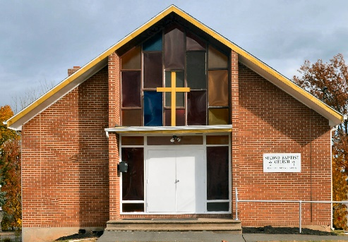
“…a house of prayer for all people. Isaiah 57:7”
New Britain, Connecticut, once known as the Hardware City of the World, is the location of Second Baptist Church. This New England city has a population of approximately 73,000 persons, New Britain is located in the central section of the state and is easily accessible to several metropolitan cities on the East Coast by the interstate system. The church is located at 55 Chapman Street on the east end of town.
Second Baptist is composed of a predominately African American membership. The history of this bible based church is a glorious story of self-sacrificing love and labor on the part of many members and others for God and His people.
The church has a membership of approximately 50. This pastorate has been endowed with many advantages including a cohesive group of hard working members. These members make up a number of vital organizations of the church including the Joint Board of deacons and trustees, Sunday School, Choirs, Bible Study, Ushers Board and other auxiliaries.
By faith in God, we will strive to win souls using Christian courage to further advance God's kingdom. Our Mission is to be a worshiping, witnessing, teaching/learning, and serving community of believers.
Second Baptist Church needs a warm and strong spiritual leader who will be an effective preacher, teacher, and worship leader. The basic direction of the pastor should be spiritual with a proven ability to preach with clarity and make the gospel relevant to people's lives. The individual must also possess a commitment toward improving the quality of life in the community. We are seeking a pastor who will grow our membership and continue to guide us in seeking a personal relationship with God through Jesus Christ. The individual must have empathy for human needs and should possess the energy and motivation to participate in a full range of church activities. This includes the ability to be a friend and confidant to church members.
Our congregation has the need for an active and confident leader in Christian education who will plan programs and make certain that they are implemented. These programs should be planned for the full range of the church membership including children, youth and adults in the church body.
The Second Baptist Community needs a minister who has the insight, capacity, and the will to assist each member of the congregation who may face a crisis, or other significant life changing event.
Our church membership has the need for a strong credible leader and theologian, who has the ability to preach meaningful and inspiring sermons that will assist people in strengthening their faith in God.
Professional Requirements:
- Must be licensed, trained and ordained in the Baptist ministry with a thorough knowledge of all Baptist doctrines and beliefs.
- Bachelor’s degree from an accredited college/seminary preferred but not mandatory.

