Lifelong Learning

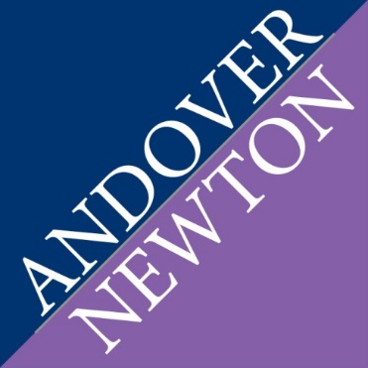
Continuing Education for Pastors in Science

The Lifelong Learning program at Yale Divinity School invites clergy to register and participate in an exciting new project: Continuing Education for Pastors in Science at Andover Newton Theological School. This project, which runs at Yale Divinity School from August 2017 through December 2017 and is supported by the American Association for the Advancement of Science, integrates science into ministry context to help clergy increase their scientific fluency and empower engagement with congregations in matters of science and religion. Participating clergy will engage in lectures, events, and reflective discussions, while creating a learning and fellowshipping clergy community with cohort colleagues.

Participants will attend selected lectures from the course Theology and Medicine, taught by Rev. S. Mark Heim, Ph.D. Visiting Professor at Yale Divinity School, and Rev. Ben Doolittle, M.D., Professor at Yale Medical School. The course explores the challenges of contemporary medicine from a theological perspective, and includes topics of traditional interest in both fields ---suffering, illness and healing--- set within the wide boundaries of human mortality and human flourishing. Outside of the classroom, participants will come together for reflection and discussion to consider the practical and contextual implications for the theoretical learning. Through this active engagement, theory and practice will be applied for ministry enrichment.

The plan for the program is as follows:

August 31, 2017 Initial Gathering
September 14, 2017 Forum on Clergy Burnout and Coping
October 12, 2017 “What Kind of Religion is Good for your Health” lecture
November 9, 2017 “Angels in America,” HIV/AIDS and Ministry
December 7, 2017 Closing Gathering

Register now by completing the attached form. A cohort of 15 clergy participants is being convened. There is no cost for participation and stipends are available to defray travel costs. Contact Rev. Debora Jackson, D.Min., Director, Lifelong Learning at Yale Divinity School by emailing Debora.Jackson@yale.edu or calling (203) 432-5330 for more information. Applications are due on July 15, 2017.
Continuing Education for Pastors in Science

Personal Information

Name

Address City, State Zip

Phone Number Email

Position Church

Registration Questions (Please feel free to use a separate sheet if necessary)
How did you hear about Continuing Education for Pastors in Science and what draws you to it?

Describe your ministry context. What are your current responsibilities?

What is your background or experience in science?

How might this program impact your ministry?

What are your hopes for this program?

